Visoka škola strukovnih studija

 za informacione i komunikacione

 Tehnologije

REDDY

<https://reddy3.000webhostapp.com/index.php>

Teodora Nedeljkovic, 5/18

Smer: Internet Tehnologije

Modul: Web programiranje

Predmet: Web programiranje PHP 1

Sadrzaj

1  UVOD 4

1.1  Korišćene tehnologije I template 4

1.2  Mapa sajta 4

1.3 Baza podataka -dizajn 6

2 FUNKCIONALNOSTI 6

2.1 Funkcionalnosti 6

3 KODOVI 25

3.1 VIEWS 25

3.11 index.php 25

3.12 reviews.php 29

3.13 movies.php 33

3.14 watchlist.php 36

3.15 profile.php 38

3.16 signin.php 42

3.17 register.php 45

3.18 survey.php 50

3.19 controlPanel.php 54

3.110 author.php 62

3.111 403.php 64

3.112 contact.php 66

3.2 LOGIKA 68

3.21 addReview.php 68

3.22 addToWatchlist.php 70

3.23 deleteMovie.php 71

3.24 getDirectors.php 72

3.25 getMoviePhotos.php 73

3.26 getMovies.php 73

3.27 insertMovie.php 74

3.28 removeFromWatchlist.php 76

3.29 topReviewers.php 77

3.210 upload.php 79

3.211 connection.php 80

3.212 updateMovie.php 81

3.213 insertMenuLink.php 83

3.213 deleteMenuLink.php 84

3.214 deleteUser.php 85

3.3  PRIKAZ 86

3.31 controlPanelContent.php 86

3.32 header.php 87

3.33 footer.php 88

3.34 movieInfo.php 89

3.35 moviesContent.php 92

3.36 reviewContent.php 94

3.37 watchlistContent.php 97

3.4 JS 98

3.5 SCSS 118

# 1  UVOD

## 1.1  Korišćene tehnologije I template

Radjeno je korišćenjem: PHP, JavaScript,Jquery, SASS/CSS, i XML u Sublime text editoru.

Template je ručno pisan.

## 1.2  Mapa sajta

<?xml version="1.0" encoding="UTF-8"?>

<urlset xmlns="http://www.sitemaps.org/schemas/sitemap/0.9" xmlns:xsi="http://www.w3.org/2001/XMLSchema-instance" xsi:schemaLocation="http://www.sitemaps.org/schemas/sitemap/0.9

 http://www.sitemaps.org/schemas/sitemap/0.9/sitemap.xsd">

    <url>

        <loc>https://reddy3.000webhostapp.com/index.php</loc>

        <lastmod>2020-03-28</lastmod>

        <changefreq>monthly</changefreq>

        <priority>0.8</priority>

    </url>

    <url>

        <loc>https://reddy3.000webhostapp.com/watchlist.php</loc>

        <lastmod>2020-03-28</lastmod>

        <changefreq>daily</changefreq>

        <priority>1</priority>

    </url>

    <url>

        <loc>https://reddy3.000webhostapp.com/movies.php</loc>

        <lastmod>2020-03-28</lastmod>

        <changefreq>daily</changefreq>

        <priority>1</priority>

    </url>

    <url>

        <loc>https://reddy3.000webhostapp.com/reviews.php</loc>

        <lastmod>2020-03-28</lastmod>

        <changefreq>dailz</changefreq>

        <priority>1</priority>

    </url>

    <url>

        <loc>https://reddy3.000webhostapp.com/author.php</loc>

        <lastmod>2020-03-28</lastmod>

        <changefreq>yearly</changefreq>

        <priority>0.1</priority>

    </url>

    <url>

        <loc>https://reddy3.000webhostapp.com/profile.php</loc>

        <lastmod>2020-03-28</lastmod>

        <changefreq>weekly</changefreq>

        <priority>0.7</priority>

    </url>

    <url>

        <loc>https://reddy3.000webhostapp.com/403.php</loc>

        <lastmod>2020-03-28</lastmod>

        <changefreq>yearly</changefreq>

        <priority>0.1</priority>

    </url>

    <url>

        <loc>https://reddy3.000webhostapp.com/signin.php</loc>

        <lastmod>2020-03-28</lastmod>

        <changefreq>yearly</changefreq>

        <priority>0.1</priority>

    </url>

    <url>

        <loc>https://reddy3.000webhostapp.com/register.php</loc>

        <lastmod>2020-03-28</lastmod>

        <changefreq>yearly</changefreq>

        <priority>0.1</priority>

    </url>

    <url>

        <loc>https://reddy3.000webhostapp.com/survey.php</loc>

        <lastmod>2020-03-28</lastmod>

        <changefreq>yearly</changefreq>

        <priority>0.1</priority>

    </url>

    <url>

        <loc>https://reddy3.000webhostapp.com/controlPanel.php</loc>

        <lastmod>2020-03-28</lastmod>

        <changefreq>monthly</changefreq>

        <priority>0.5</priority>

    </url>

    <url>

        <loc>https://reddy3.000webhostapp.com/contact.php</loc>

        <lastmod>2020-03-28</lastmod>

        <changefreq>yearly</changefreq>

        <priority>0.1</priority>

    </url>

</urlset>

## 1.3 Baza podataka -dizajn

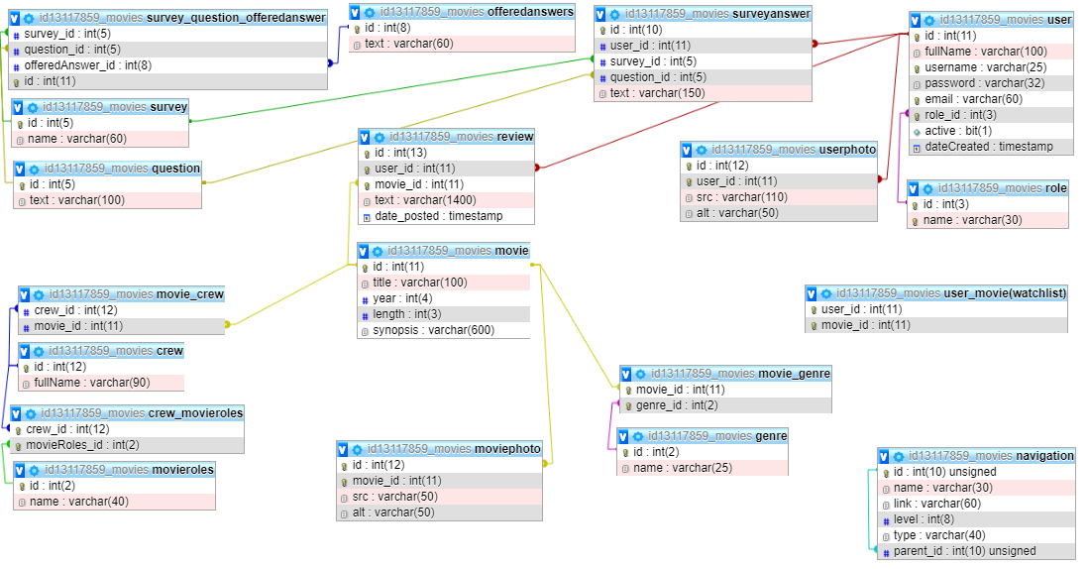

 User_movie(watchlist) je povezan sa movie (id) I user(id) kao strani kljuc, uprkos tome sto na slici nisu iscrtane linije.

# 2 FUNKCIONALNOSTI

## 2.1 Funkcionalnosti

**Index stranica**

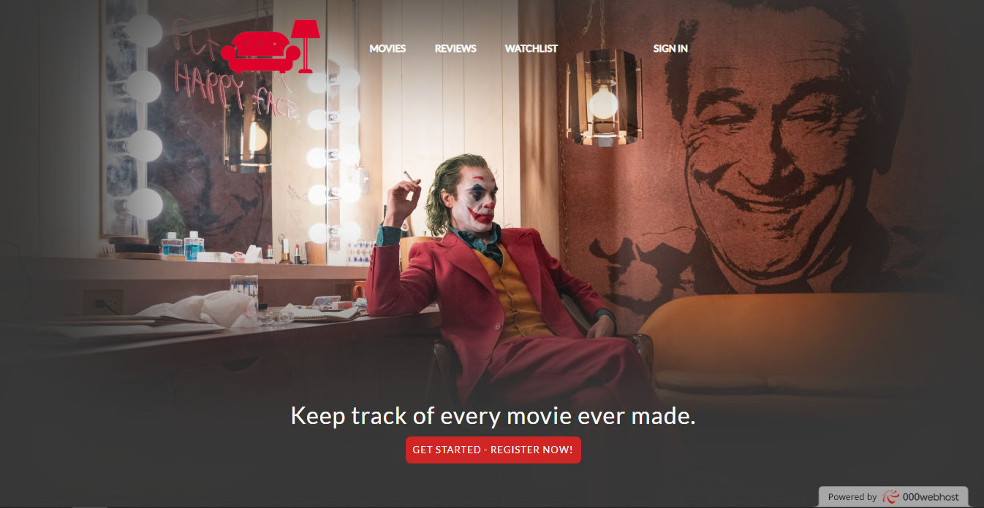

 U gornjem desnom uglu se nalazi link za sign in stranicu za neulogovanog korisnika.

Za ulogovanog nalazi se njegov username I hoverom se dobija opcija za sign out I link ka njegovom profilu.

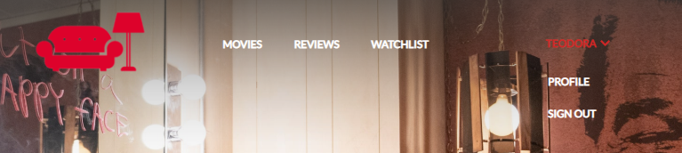

Za autorizovanog korisnika, tj admina, nalazi se dodatni link ka kontrolnom panelu.

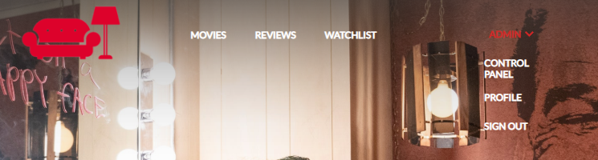

Zatim se nalazi statički blok koji void ka ostalim stranicama. I link ka stranici za registraciju.

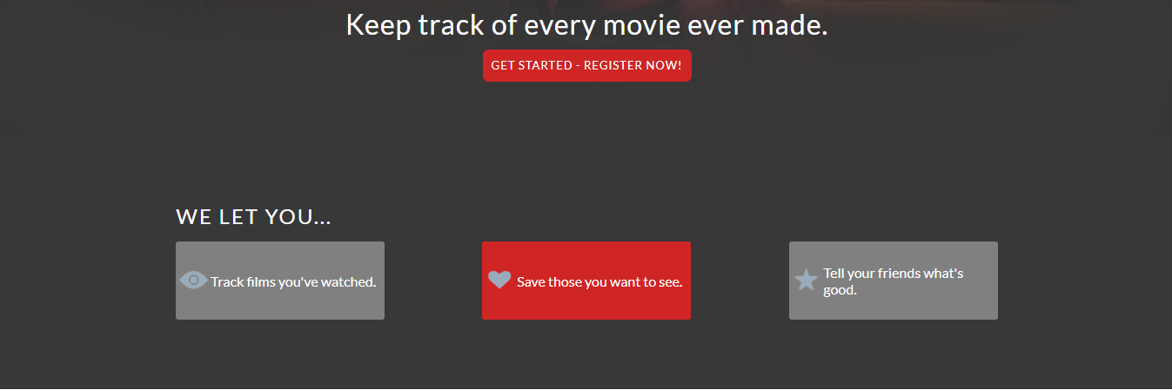

Blok koji dinamički prikazuje najnovije 3 dodate recenzije. Sa desne strane prikazuju se najviše 7 korisnika sa najvećim brojem napisanih recentija, njihov username I profilna slika.

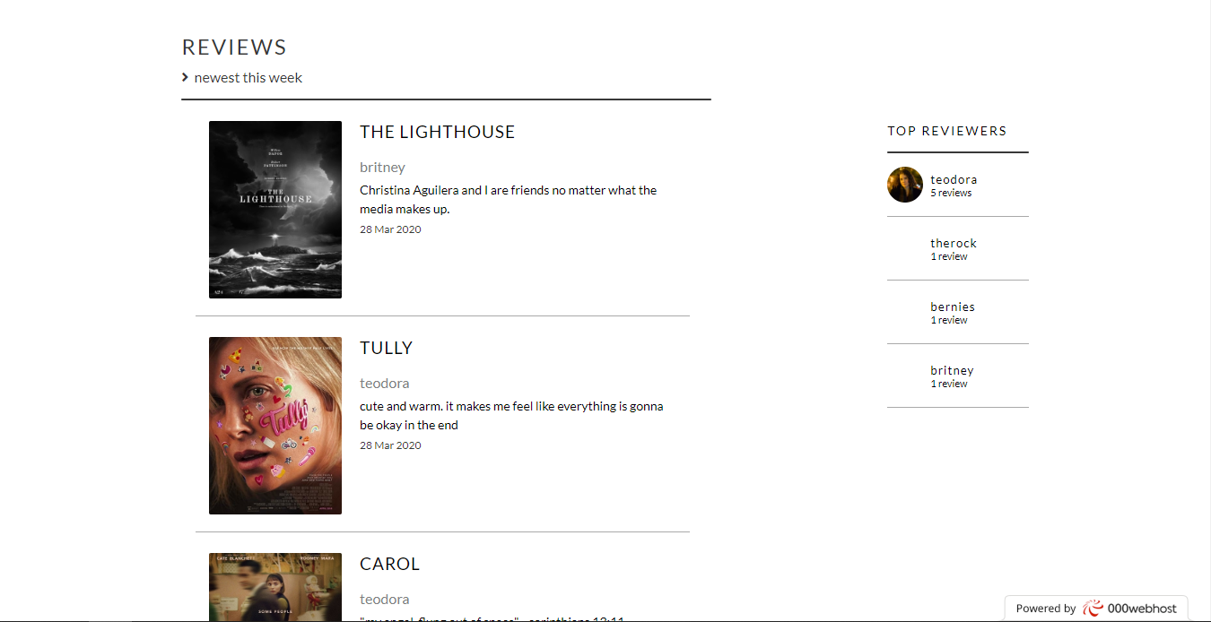

Blok koji vodi ka stranici za anketu. Ako niste ulogovani, piše tekst koji apeluje na to da treba da se ulogujete. Ako je anketa već urađena, pisaće tekst zahvalnosti.

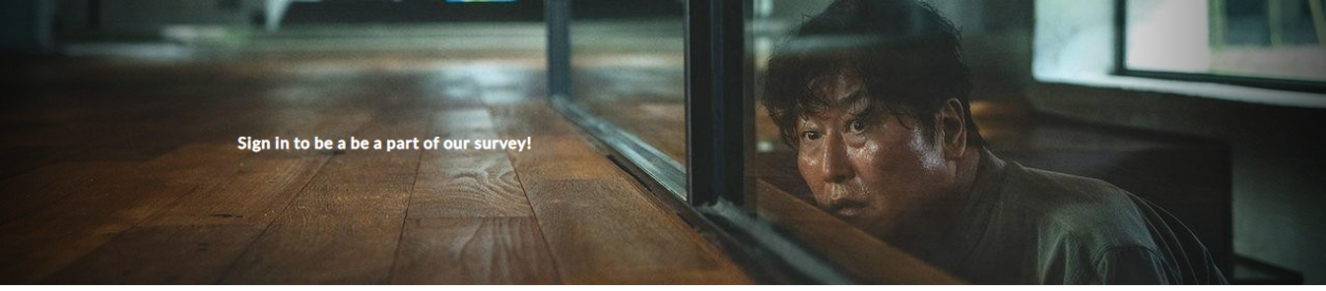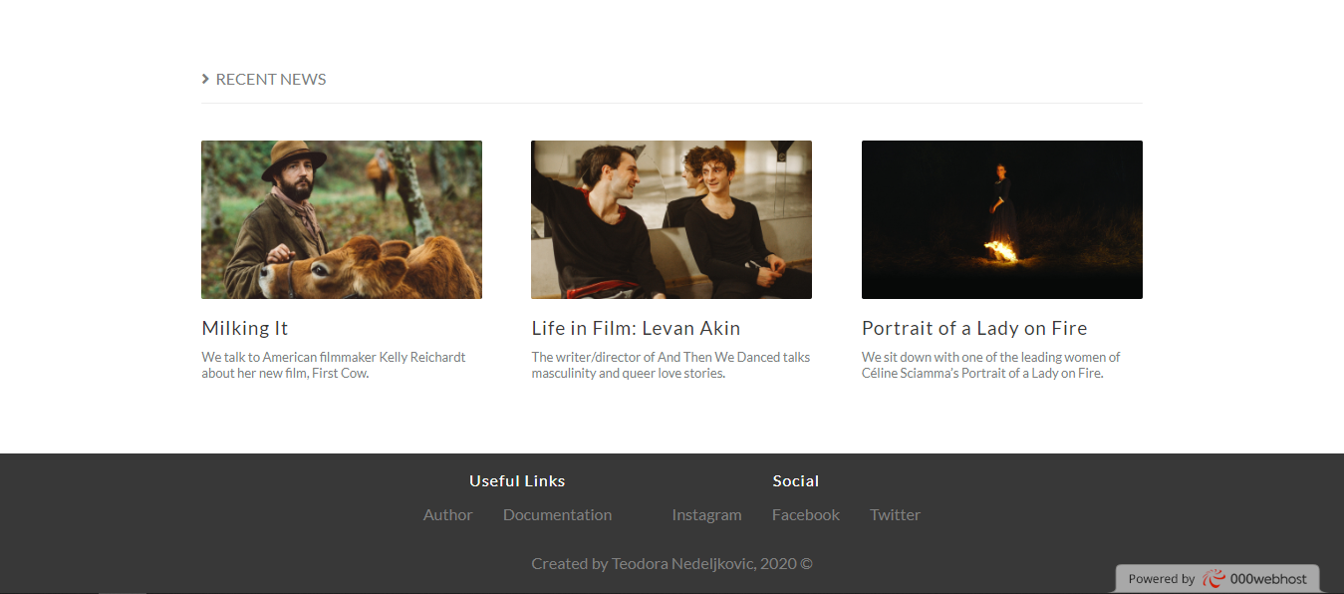

Statički blok vesti.

Footer dinamički realizovan iz baze, isti za svaku stranicu.

**SIGN IN STRANICA**

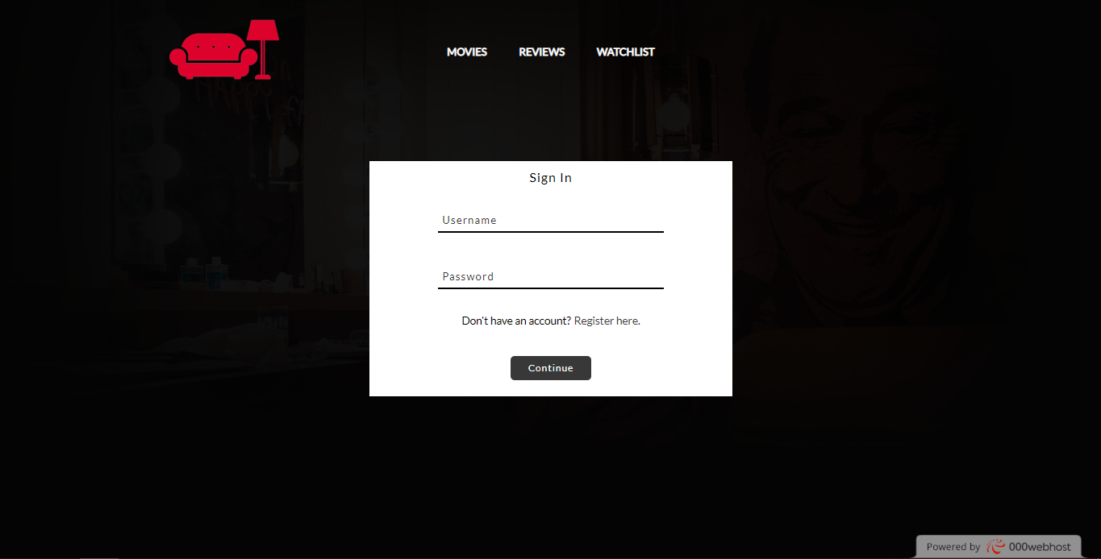

Ukoliko korisnik pokušava da se uloguje nepostojećim username koji postoji ali se ne slaže sa šifrom, piše takvo obaveštenje. Pojavljuje se na klik dugmeta.

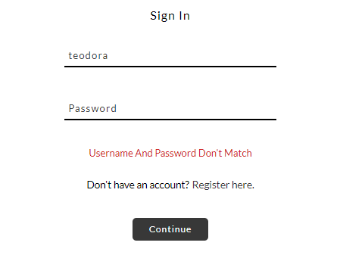

Ukoliko korisnik pokušava da se uloguje nepostojećim username-om, stiže mu takvo obaveštenje. Pojavljuje se na klik dugmeta.

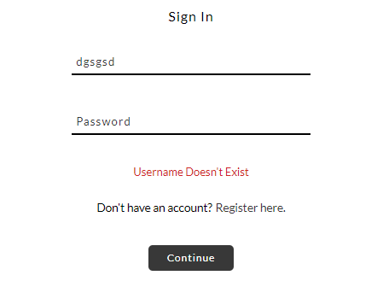

**REGISTER STRANICA**

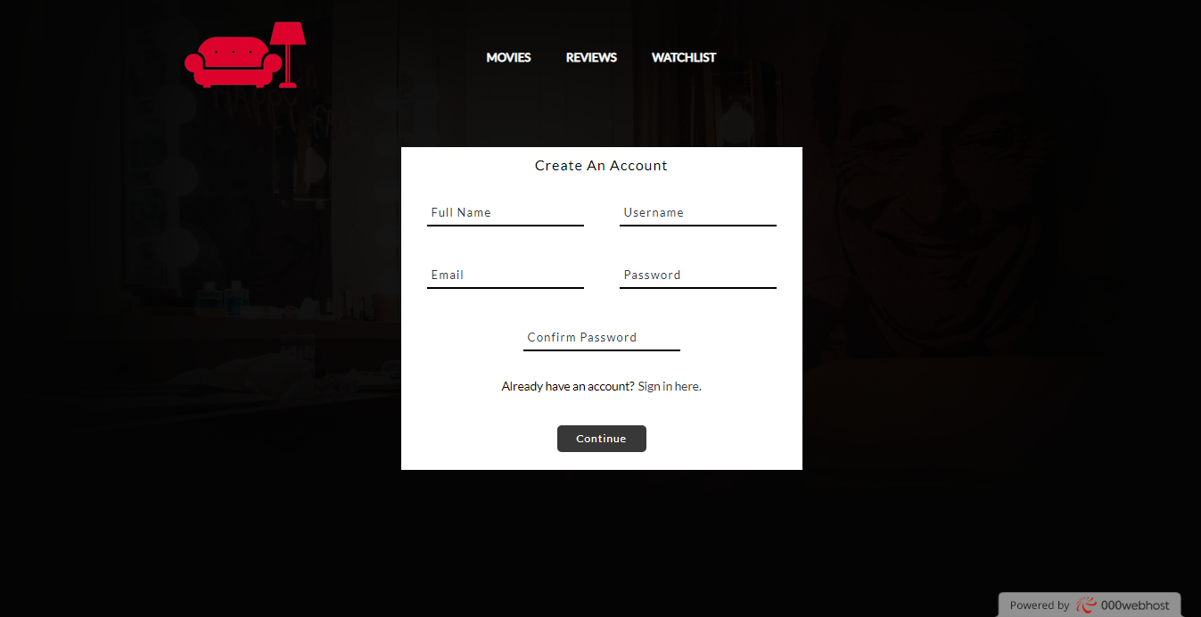

Ukoliko je username zauzet,stiže obaveštenje na klik, ista funkcionalnost I za email.

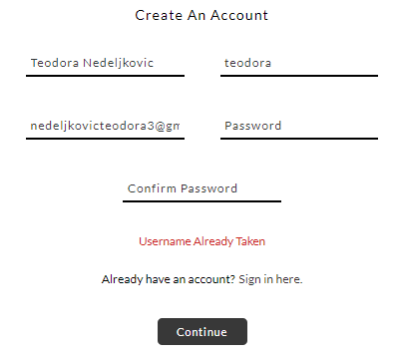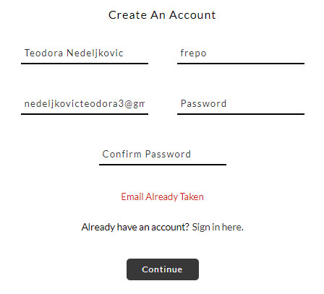

**MOVIES STRANICA**

Slajder dve slike,statički.

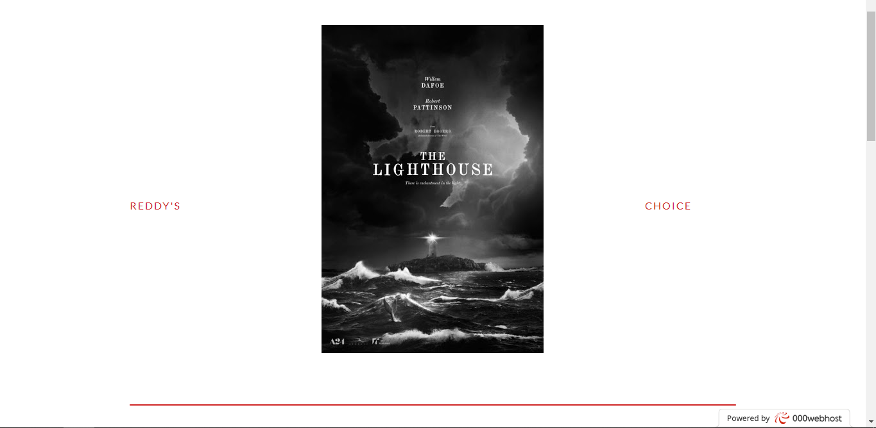

Dinamički prikzani svi filmovi iz baze, 16 po stranici. Sortiranje moguće po najstarijem ili najnovijem.

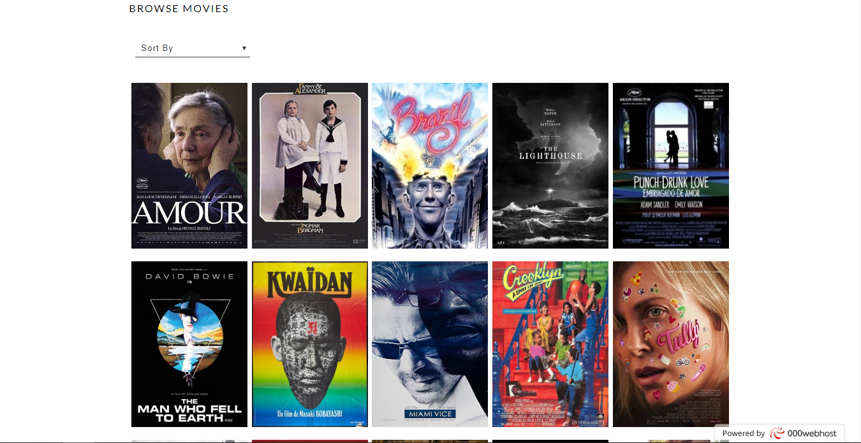

Klikom na bilo koji od filma se pojavljuje info blok sa informacijiama o ljudima koji su radili na njemu, naslovu,godini izdanja,sinopsisu…

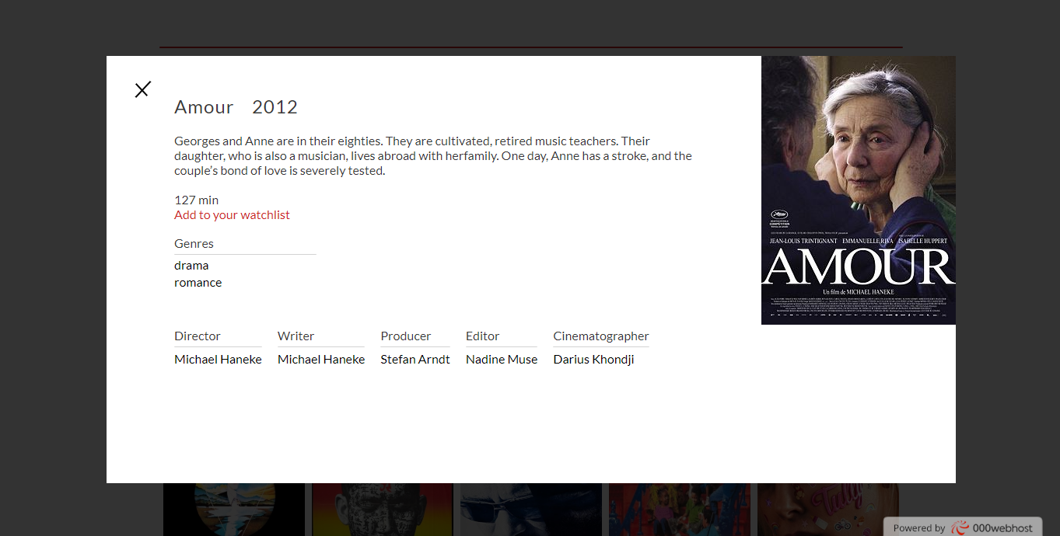

Klik za dodavanje u watchlistu se ovde nalazi.

**REVIEWS STRANICA**

Najnovijih 7 filmova za koje su napisane recenzije.

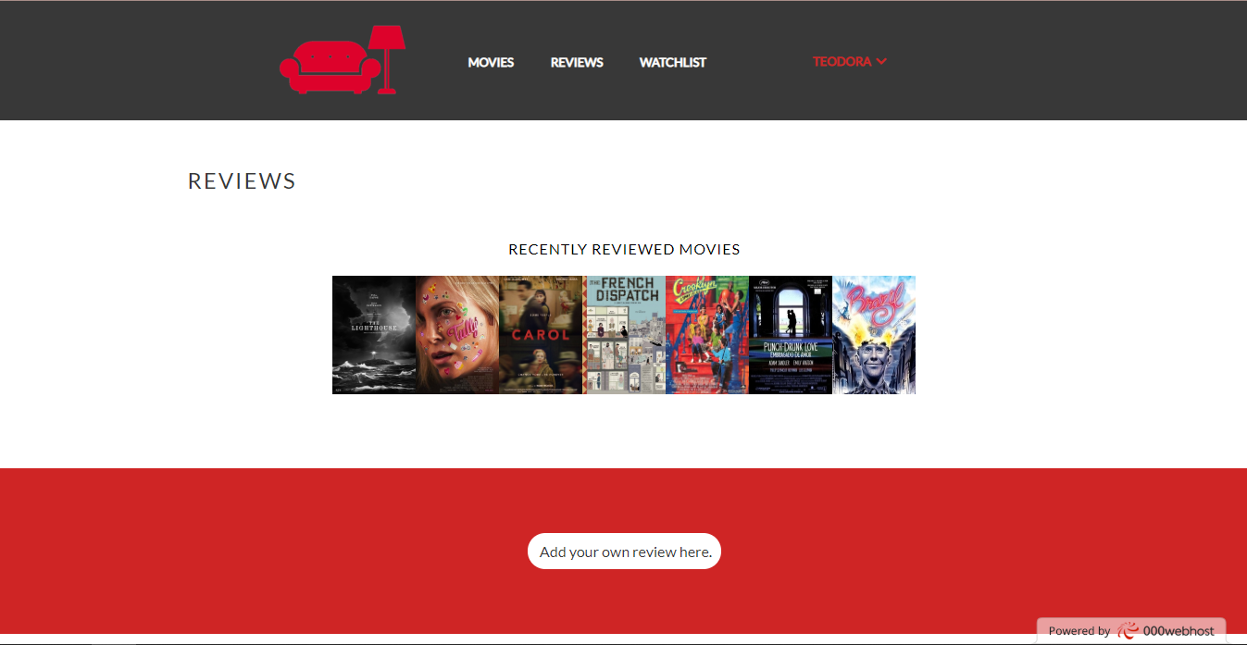

Nalazi se klik za dodavanje sopstvene recenzije. Ako nije ulogovan, nalazi se link ka sign in stranici kako bi posle dodao recenziju.



Otvoren blok za dodavanje recenzije. Dinamička padajuća lista popunjena filmovima iz baze.

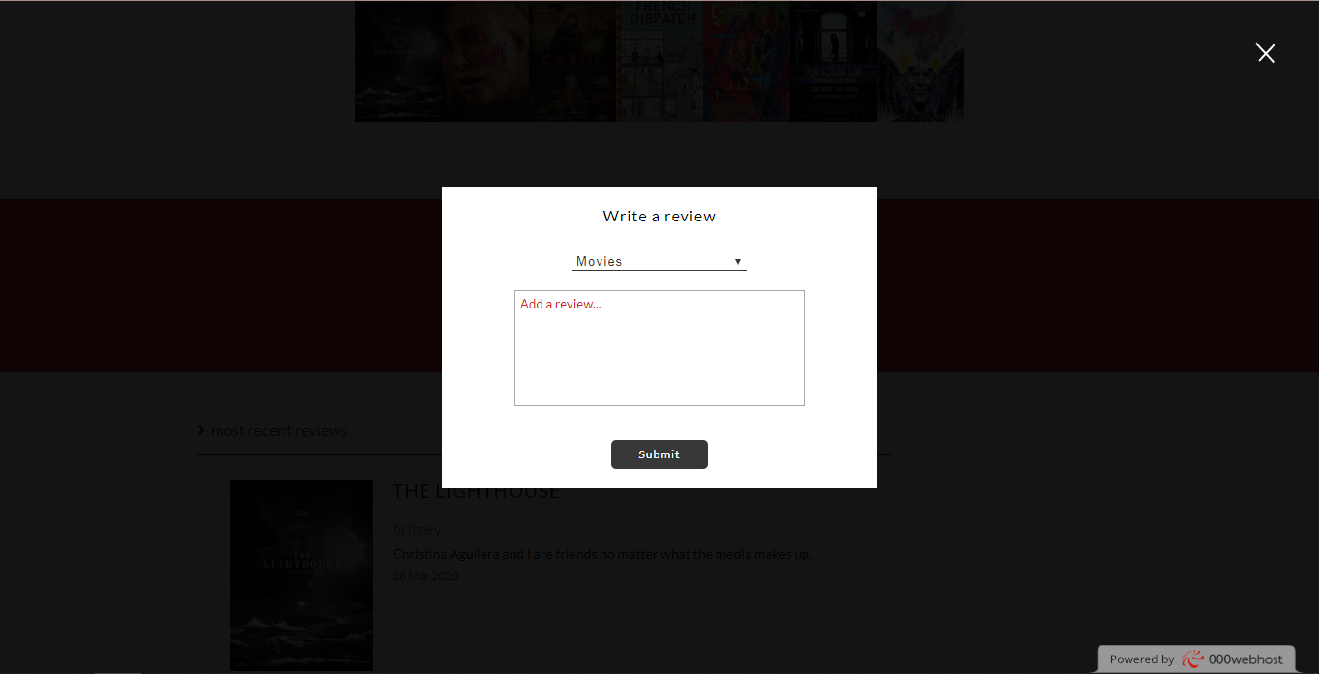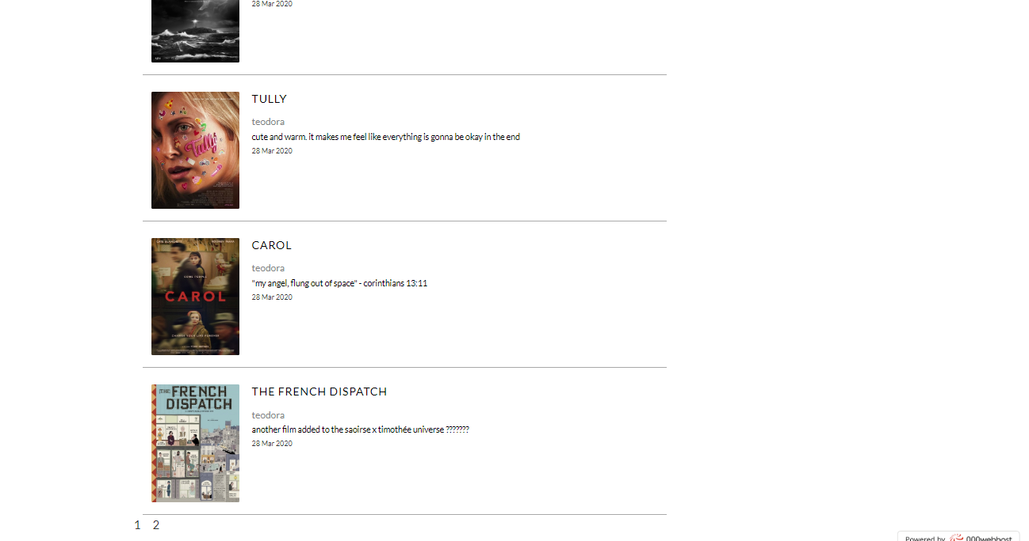

Sve recenzije napisane, 4 po stranici.Informacije o tome ko je napisao, sta I za koji film.

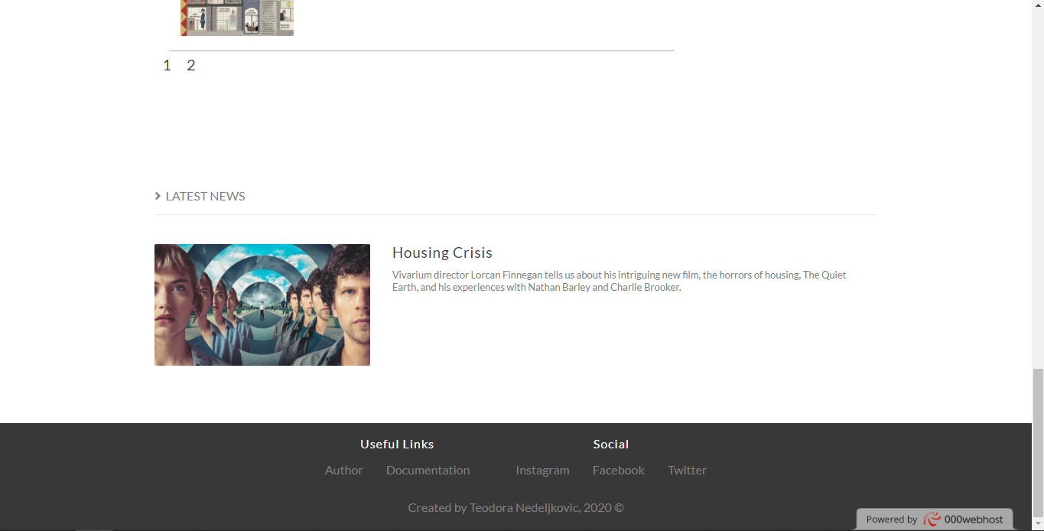

Statički blok sa vestima.

**WATCHLIST STRANICA**

Ako je korisnik ulogovan, a nema filmove u watchlisti nalazi se link ka straanici sa filmovima.

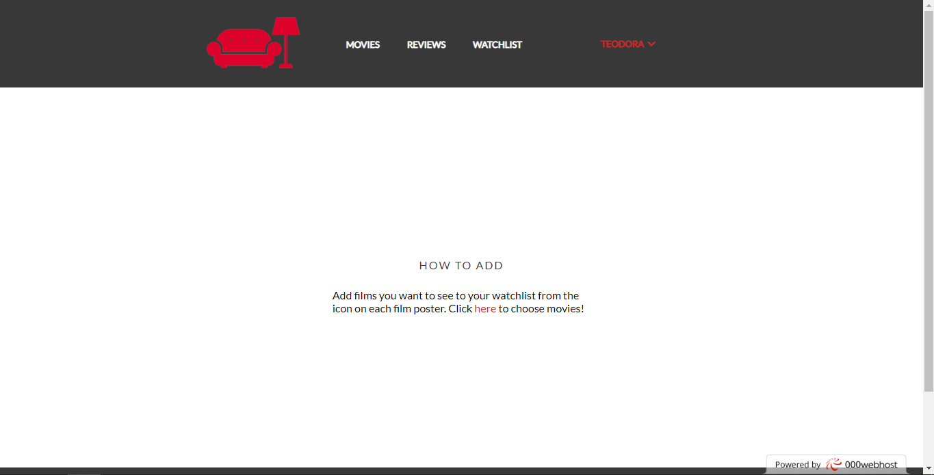

Filmovi iz watchliste korisnika I dugme X za brisanje filma iz liste.

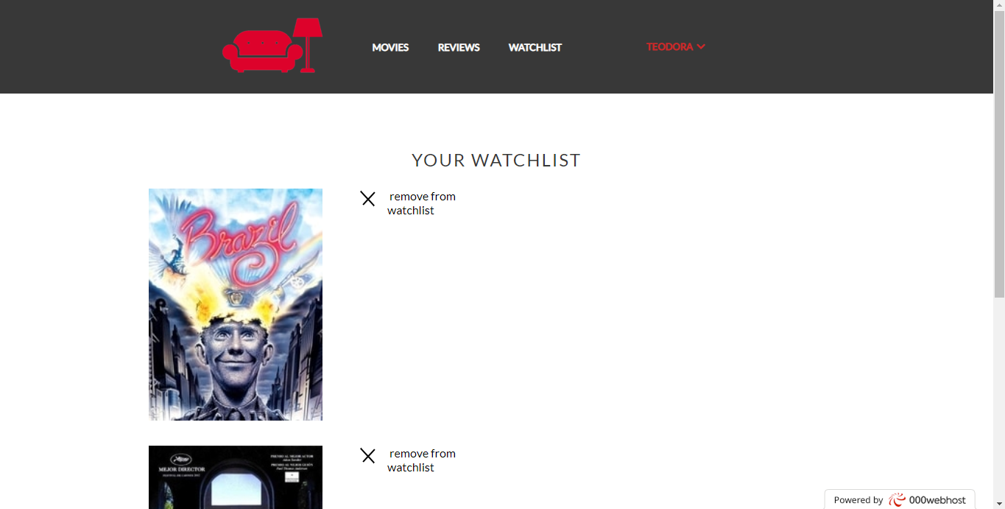

**PROFILE STRANICA**

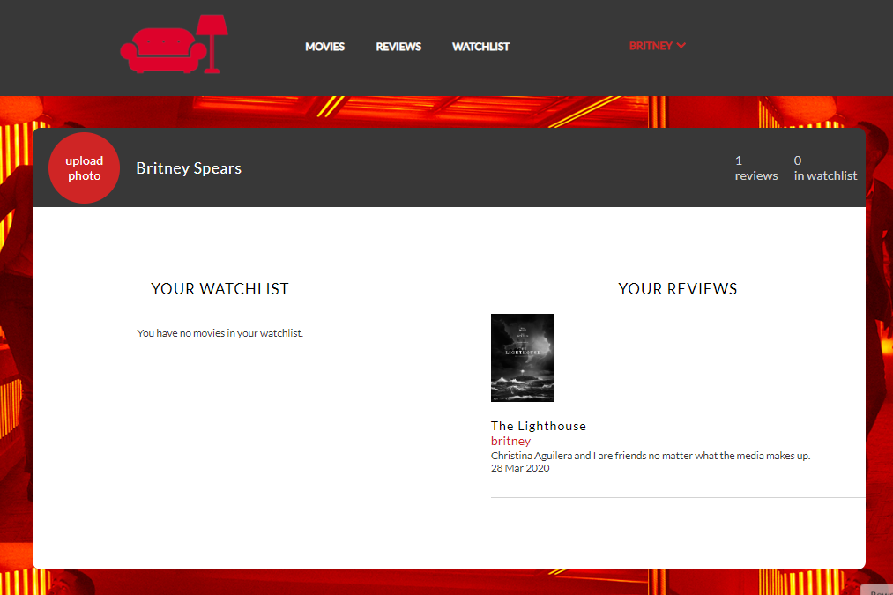

Mogućnost dodavanja profilne slike, prikaz I broj napisanih recenzija I filmova u watchlisti. Pored mesta za sliku nalazi se puno ime korisnika.

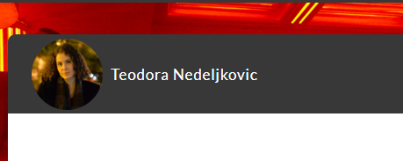

**CONTROL PANEL STRANICA**

Uvid u statistiku. Mogućnost update,brisanja I dodavanja filma.

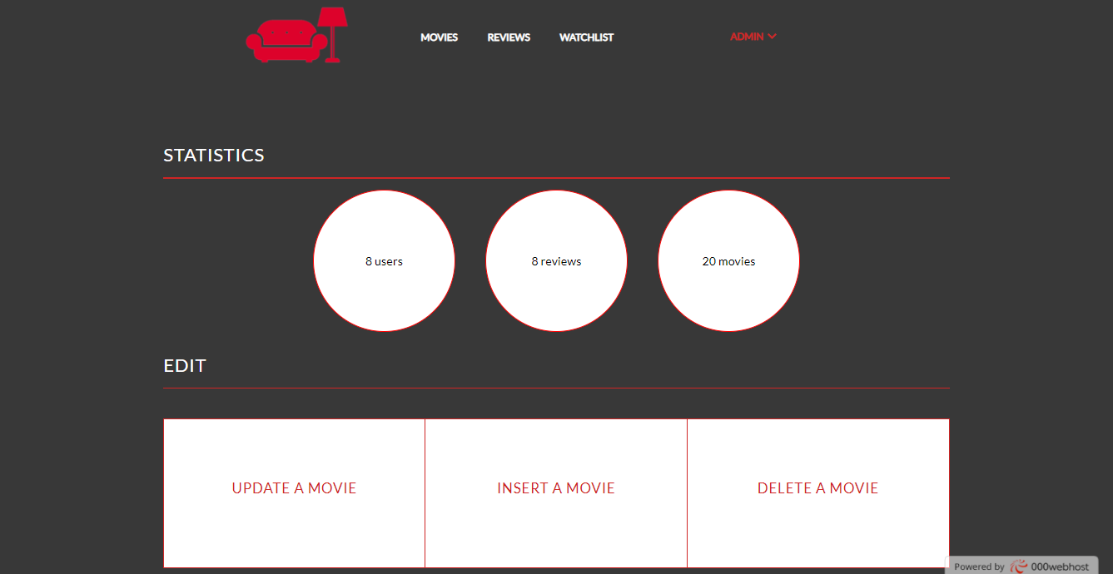

Prilikom brisanja pojavljuje se autocomplete blok sa predlozima. I ime filma I režisera.

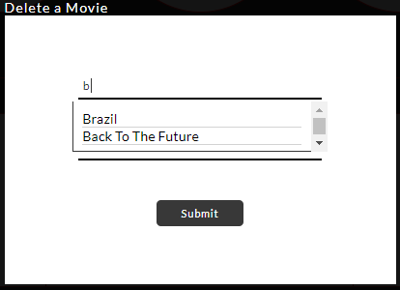

Insert filma, svi parametric obavezni.

Funkcionalnost uploadovanja postera-filmske slike.

Mogućnost odabira vise žanrova.

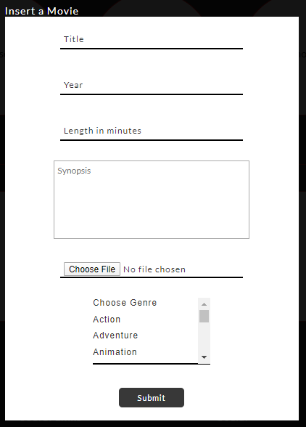

Upravljanje menijem- dodavanje novog linka i brisanje

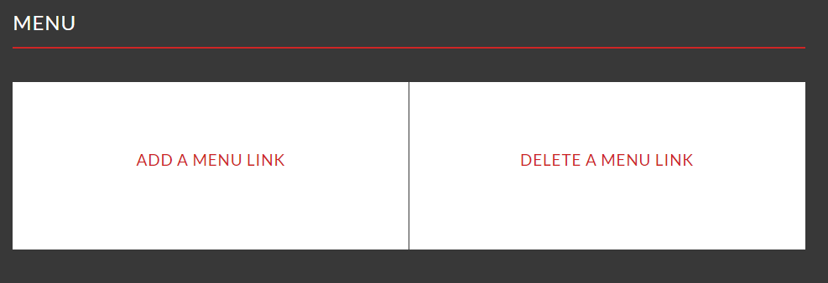

Add menu link forma:

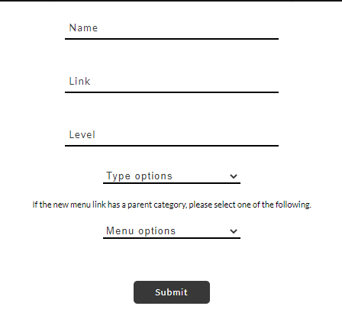

Delete menu link forma:

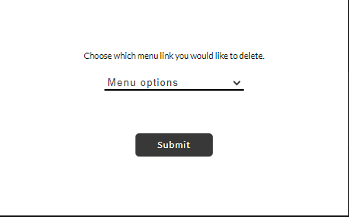

Opcija za brisanje usera:

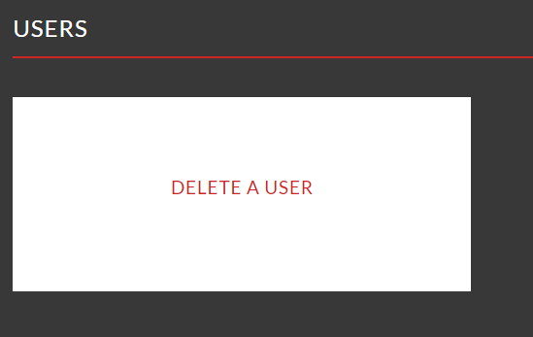

Forma za brisanje korisnika:



**CONTACT STRANICA**

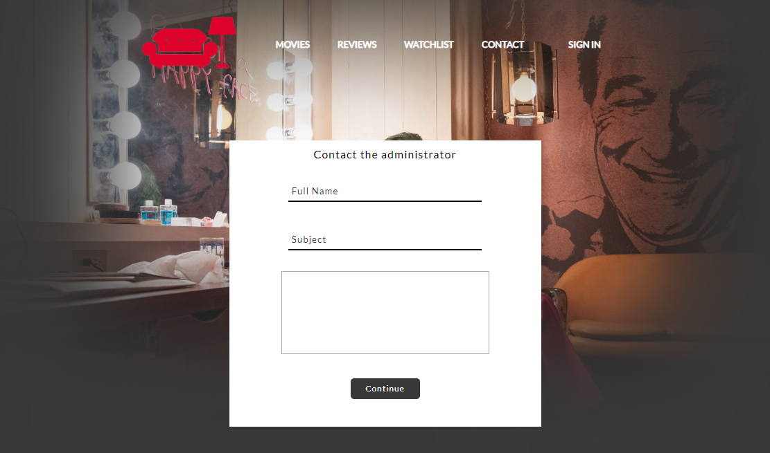

Kao I za svaku formu, validacija podataka I sa klijentske I serverske strane.

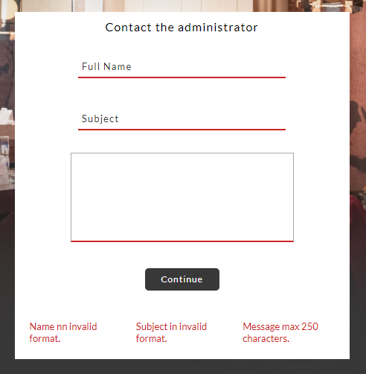

**STRANICA 403**

Pri pristupu signin,register ako jesu već ulogovani.

Pri pristupu profile.php ako nisu ulogovani.

Pristupu kontrolnom panelu ako nije role admin.

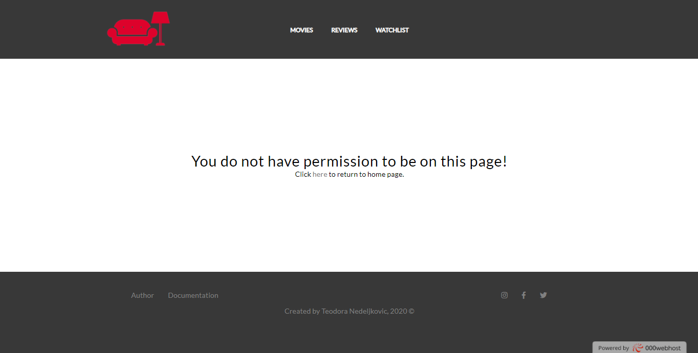

**AUTOR STRANICA**

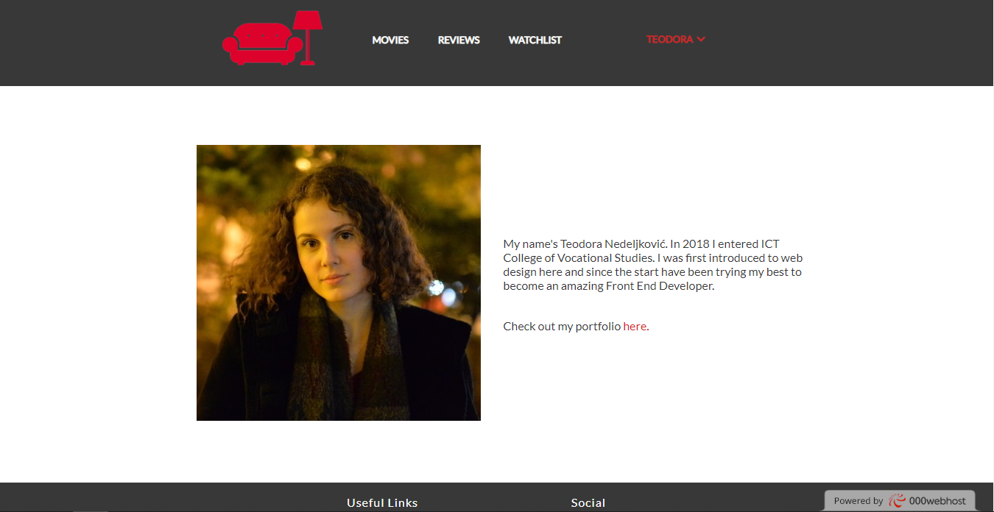

# 3 KODOVI

## 3.1 VIEWS

### 3.11 index.php

<?php

    session_start();

    require "connection.php";

    if (isset($_GET['logout'])) {

        session_destroy();

        unset($_SESSION['username']);

        header("Refresh:0; url=index.php");

    }

?>

<!DOCTYPE html>

<html>

<head>

    <title>Reddy – Home Page</title>

    <link rel="stylesheet" type="text/css" href="assets/css/style.css"/>

    <link rel="stylesheet" href="https://use.fontawesome.com/releases/v5.8.2/css/all.css" integrity="sha384-oS3vJWv+0UjzBfQzYUhtDYW+Pj2yciDJxpsK1OYPAYjqT085Qq/1cq5FLXAZQ7Ay" crossorigin="anonymous"/>

    <meta charset="utf-8"/>

    <meta name="description" content=""/>

    <meta name="keywords" content=""/>

    <meta name="author" content=" Teodora Nedeljković"/>

    <meta name="viewport" content="width=device-width, initial-scale=1.0"/>

    <link rel="shortcut icon" href="assets/img/favicon.ico"/>

</head>

<body>

    <div id="poster">

        <?php include "header.php"; ?>

        <div id="posterTitle">

            <h1>Keep track of every movie ever made.</h1>

            <?php

                if(!isset($_SESSION['username'])){

                    echo '<div><a href="register.php" class="register">Get started - Register now!</a></div>';

                }

            ?>

        </div>

    </div>

    <div id="highlights">

        <div class="wrapper">

            <h2>WE LET YOU...</h2>

            <div id="highlightsBlock">

                <a href="movies.php" class="highlight watched">

                    <span class="icons icon-watched"></span>

                    <p>Track films you've watched.</p>

                </a>

                <a href="watchlist.php" class="highlight seen">

                    <span class="icons icon-seen"></span>

                    <p>Save those you want to see.</p>

                </a>

                <a href="reviews.php" class="highlight reviewed">

                    <span class="icons icon-reviewed"></span>

                    <p>Tell your friends what's good.</p>

                </a>

            </div>

        </div>

    </div>

    <div class="content">

        <div class="wrapper">

            <div id="reviews">

                <div class="title">

                    <h2><a href="reviews.php">REVIEWS</a></h2>

                    <p><i class="fas fa-angle-right"></i>&nbsp;&nbsp;newest this week</p>

                </div>

                <hr/>

                <div id="reviewBlock">

                    <?php

                        include "reviewContent.php";

                        review_top($connection,3);

                    ?>

                </div>

            </div>

            <div id="topReviewers">

                <h2>TOP REVIEWERS</h2>

                <hr/>

                <div id="topReviewersBlock">

                    <?php include "logic/topReviewers.php" ?>

                </div>

            </div>

        </div>

    </div>

    <div id="survey">

        <div class="wrapper">

            <div id="surveyBlock">

                <?php

                    $username = $_SESSION['username'];

                    $userSelect = $connection->prepare("SELECT id FROM user WHERE username=:user");

                    $userSelect->bindParam(":user",$username);

                    $userSelect->execute();

                    $userSelectResult = $userSelect->fetch();

                    $userId = $userSelectResult['id'];

                    $checkSelect = $connection->prepare("SELECT user_id FROM surveyanswer WHERE user_id=:userId");

                    $checkSelect->bindParam(":userId",$userId);

                    $checkSelect->execute();

                    $checkResult = $checkSelect->fetchAll();

                    if(count($checkResult)>0){

                        echo "<h1 style='color:white; font-size:17px;'>Thank you for participating in the survey.</h1>";

                    } else{

                        echo "<p>Be a part of our survey <a href='survey.php'>here</a>!</p>";

                    }

                ?>

            </div>

        </div>

    </div>

    <div id="news">

        <div class="wrapper">

            <div class="title">

                <p><i class="fas fa-angle-right"></i>&nbsp;&nbsp;RECENT NEWS</p>

                <hr/>

            </div>

            <div id="newsBlock">

                <div class="news">

                    <a href="#"><img src="assets/img/news/1.jpg" alt=""/></a>

                    <div>

                        <a href="#"><h3>Milking It</h3></a>

                        <p>We talk to American filmmaker Kelly Reichardt about her new film, First Cow.</p>

                    </div>

                </div>

                <div class="news">

                    <a href="#"><img src="assets/img/news/2.jpg" alt=""/></a>

                    <div>

                        <a href="#"><h3>Life in Film: Levan Akin</h3></a>

                        <p>The writer/director of And Then We Danced talks masculinity and queer love stories.</p>

                    </div>

                </div>

                <div class="news">

                    <a href="#"><img src="assets/img/news/3.jpg" alt=""/></a>

                    <div>

                        <a href="#"><h3>Portrait of a Lady on Fire</h3></a>

                        <p>We sit down with one of the leading women of Céline Sciamma’s Portrait of a Lady on Fire.</p>

                    </div>

                </div>

            </div>

        </div>

    </div>

    <?php include "footer.php"; ?>

    <div id="signInBlock">

        <div class="formClose close">

            <span></span>

            <span></span>

        </div>

        <form method="POST" action="signin.php" id="formSignIn" onsubmit="return proveraSignIn()">

            <div><h4>Sign In</h4></div>

            <div><input type="text" name="usernameSignIn" id="usernameSignIn" placeholder="Username"/></div>

            <div><input type="password" name="passwordSignIn" id="passwordSignIn" placeholder="Password"/></div>

            <div id="dugmeSignInBlock"><input type="submit" name="dugmeSignIn" id="dugmeSignIn" value="Continue"></div>

        </form>

    </div>

    <div id="registerBlock">

        <div class="formClose close">

            <span></span>

            <span></span>

        </div>

        <form method="POST" action="register.php" id="formRegister" onsubmit="return proveraRegister()">

            <div><h4>Create An Account</h4></div>

            <div><input type="text" name="fullName" id="fullName" placeholder="Full Name"/></div>

            <div><input type="text" name="usernameRegister" id="usernameRegister" placeholder="Username"/></div>

            <div><input type="email" name="emailRegister" id="emailRegister" placeholder="Email"/></div>

            <div><input type="password" name="passwordRegister" id="passwordRegister" placeholder="Password"/></div>

            <div><input type="password" name="passwordConfirm" id="passwordConfirm" placeholder="Confirm Password"/></div>

            <div><input type="submit" name="dugmeRegister" id="dugmeRegister" value="Continue"></div>

        </form>

    </div>

    <script src="assets/js/jquery.js"></script>

    <script  src="assets/js/main.js"></script>

</body>

</html>

### 3.12 reviews.php

<?php

    session_start();

    require "connection.php";

    include "logic/addReview.php";

?>

<!DOCTYPE html>

<html>

<head>

    <title>Reviews</title>

    <link rel="stylesheet" type="text/css" href="assets/css/style.css"/>

    <link rel="stylesheet" href="https://use.fontawesome.com/releases/v5.8.2/css/all.css" integrity="sha384-oS3vJWv+0UjzBfQzYUhtDYW+Pj2yciDJxpsK1OYPAYjqT085Qq/1cq5FLXAZQ7Ay" crossorigin="anonymous"/>

    <meta charset="utf-8"/>

    <meta name="description" content=""/>

    <meta name="keywords" content=""/>

    <meta name="author" content=" Teodora Nedeljković"/>

    <meta name="viewport" content="width=device-width, initial-scale=1.0"/>

    <link rel="shortcut icon" href="assets/img/favicon.ico"/>

</head>

<body>

    <?php include "header.php"; ?>

    <div class="content">

        <div class="wrapper">

            <div id="reviews">

                <div>

                    <h2>REVIEWS</h2>

                    <div id="reviewedMovies">

                        <h4>recently reviewed movies</h4>

                        <div>

                            <?php

                                include "reviewContent.php";

                                reviewed_movies_top($connection,8);

                            ?>

                        </div>

                    </div>

                </div>

            </div>

        </div>

    </div>

    <div id="addReviewLink">

        <?php

            if(isset($_SESSION['username'])){

                echo "<p id='addReview'>&nbsp;Add your own review here.</p>";

            } else{

                echo "<p><a href='signin.php'>&nbsp;Sign in</a> to add your review.</p>";

            }

        ?>

    </div>

    <div class="content">

        <div class="wrapper">

            <div id="reviews">

                <div id="reviewBlock">

                    <p><i class="fas fa-angle-right"></i>&nbsp;&nbsp;most recent reviews</p>

                    <hr/>

                    <?php

                        review_pages($connection);

                    ?>

                </div>

            </div>

        </div>

    </div>

    <div id="news">

        <div class="wrapper">

            <div class="title">

                <p><i class="fas fa-angle-right"></i>&nbsp;&nbsp;LATEST NEWS</p>

                <hr/>

            </div>

            <div id="newsBlock">

                <div class="news" id="reviewNews">

                    <a href="#"><img src="assets/img/news/4.jpg" alt="news"/></a>

                    <div>

                        <a href="#"><h3>Housing Crisis</h3></a>

                        <p>Vivarium director Lorcan Finnegan tells us about his intriguing new film, the horrors of housing, The Quiet Earth, and his experiences with Nathan Barley and Charlie Brooker. </p>

                    </div>

                </div>

            </div>

        </div>

    </div>

    <div id="addReviewBlock">

        <div class="formClose close">

            <span></span>

            <span></span>

        </div>

        <form action="<?php echo $_SERVER['PHP_SELF']?>" method="POST" name="addReviewForm" onsubmit="return reviewProvera()">

            <h4>Write a review</h4>

            <div>

                <select id="movieSelect" name="movieSelect">

                    <option value='0'>Movies</option>

                    <?php

                        $moviesSelectQuery = $connection->prepare("SELECT * FROM movie");

                        $moviesSelectQuery->execute();

                        $moviesSelectResult = $moviesSelectQuery->fetchAll();

                        foreach ($moviesSelectResult as $movie) {

                            $title = $movie['title'];

                            $id = $movie['id'];

                            echo "<option value='{$id}'>{$title}</option>";

                        }

                    ?>

                </select>

            </div>

            <div>

                <textarea placeholder="Add a review..." id="reviewText" name="reviewText"></textarea>

            </div>

            <div><input type="submit" name="submitReview" id="submitReview"/></div>

        </form>

    </div>

    <?php include "footer.php"; ?>

    <div id="signInBlock">

        <div class="formClose close">

            <span></span>

            <span></span>

        </div>

        <form method="POST" action="#" id="formSignIn">

            <div><h4>Sign In</h4></div>

            <div><input type="text" name="usernameSignIn" id="usernameSignIn" placeholder="Username"/></div>

            <div><input type="password" name="passwordSignIn" id="passwordSignIn" placeholder="Password"/></div>

            <div><input type="button" name="dugmeSignIn" id="dugmeSignIn" value="Continue"></div>

        </form>

    </div>

    <div id="registerBlock">

        <div class="formClose close">

            <span></span>

            <span></span>

        </div>

        <form method="POST" action="#" id="formRegister">

            <div><h4>Create An Account</h4></div>

            <div><input type="text" name="fullName" id="fullName" placeholder="Full Name"/></div>

            <div><input type="text" name="usernameRegister" id="usernameRegister" placeholder="Username"/></div>

            <div><input type="email" name="emailRegister" id="emailRegister" placeholder="Email"/></div>

            <div><input type="password" name="passwordRegister" id="passwordRegister" placeholder="Password"/></div>

            <div><input type="password" name="passwordConfirm" id="passwordConfirm" placeholder="Confirm Password"/></div>

            <div><input type="button" name="dugmeRegister" id="dugmeRegister" value="Continue"></div>

        </form>

    </div>

    <script src="assets/js/jquery.js"></script>

    <script  src="assets/js/main.js"></script>

</body>

</html>

### 3.13 movies.php

<?php

    session_start();

    require "connection.php";

?>

<!DOCTYPE html>

<html>

<head>

    <title>Movies</title>

    <link rel="stylesheet" type="text/css" href="assets/css/style.css"/>

    <link rel="stylesheet" href="https://use.fontawesome.com/releases/v5.8.2/css/all.css" integrity="sha384-oS3vJWv+0UjzBfQzYUhtDYW+Pj2yciDJxpsK1OYPAYjqT085Qq/1cq5FLXAZQ7Ay" crossorigin="anonymous"/>

    <meta charset="utf-8"/>

    <meta name="description" content=""/>

    <meta name="keywords" content=""/>

    <meta name="author" content=" Teodora Nedeljković"/>

    <meta name="viewport" content="width=device-width, initial-scale=1.0"/>

    <link rel="shortcut icon" href="assets/img/favicon.ico"/>

</head>

<body>

    <?php include "header.php"; ?>

    <div id="movies">

        <div class="wrapper">

            <div id="topMovies">

                <h4>Reddy's</h4>

                <div id="topMoviesBlock">

                </div>

                <h4>Choice</h4>

            </div>

            <hr class="marginBorder"/>

            <h4>Browse movies</h4>

            <div id="manipulateMovies">

                <div id="sortFilterBlock" class="input-field">

                    <select name="sort" id="sortMovies" >

                        <option value="0">Sort By</option>

                        <option value="oldest">Oldest</option>

                        <option value="newest">Newest</option>

                    </select>

                </div>

            </div>

            <div id="moviesBlock">

                <?php include "moviesContent.php"; ?>

            </div>

            <div id="infoBlock">

            </div>

        </div>

    </div>

    <?php include "footer.php"; ?>

    <div id="signInBlock">

        <div class="formClose close">

            <span></span>

            <span></span>

        </div>

        <form method="POST" action="#" id="formSignIn">

            <div><h4>Sign In</h4></div>

            <div><input type="text" name="usernameSignIn" id="usernameSignIn" placeholder="Username"/></div>

            <div><input type="password" name="passwordSignIn" id="passwordSignIn" placeholder="Password"/></div>

            <div><input type="button" name="dugmeSignIn" id="dugmeSignIn" value="Continue"></div>

        </form>

    </div>

    <div id="registerBlock">

        <div class="formClose close">

            <span></span>

            <span></span>

        </div>

        <form method="POST" action="#" id="formRegister">

            <div><h4>Create An Account</h4></div>

            <div><input type="text" name="fullName" id="fullName" placeholder="Full Name"/></div>

            <div><input type="text" name="usernameRegister" id="usernameRegister" placeholder="Username"/></div>

            <div><input type="email" name="emailRegister" id="emailRegister" placeholder="Email"/></div>

            <div><input type="password" name="passwordRegister" id="passwordRegister" placeholder="Password"/></div>

            <div><input type="password" name="passwordConfirm" id="passwordConfirm" placeholder="Confirm Password"/></div>

            <div><input type="button" name="dugmeRegister" id="dugmeRegister" value="Continue"></div>

        </form>

    </div>

    <script src="assets/js/jquery.js"></script>

    <script src="assets/js/main.js"></script>

</body>

</html>

### 3.14 watchlist.php

<?php

    session_start();

    require "connection.php";

?>

<!DOCTYPE html>

<html>

<head>

    <title>Watchlist</title>

    <link rel="stylesheet" type="text/css" href="assets/css/style.css"/>

    <link rel="stylesheet" href="https://use.fontawesome.com/releases/v5.8.2/css/all.css" integrity="sha384-oS3vJWv+0UjzBfQzYUhtDYW+Pj2yciDJxpsK1OYPAYjqT085Qq/1cq5FLXAZQ7Ay" crossorigin="anonymous"/>

    <meta charset="utf-8"/>

    <meta name="description" content=""/>

    <meta name="keywords" content=""/>

    <meta name="author" content=" Teodora Nedeljković"/>

    <meta name="viewport" content="width=device-width, initial-scale=1.0"/>

    <link rel="shortcut icon" href="assets/img/favicon.ico"/>

</head>

<body>

    <?php include "header.php"; ?>

    <?php include "movieInfo.php"; ?>

    <div id="watchlist">

        <div class="wrapper">

            <div id="watchlistBlock">

                <?php include "watchlistContent.php" ?>

            </div>

            <div id="infoBlock">

            </div>

        </div>

    </div>

    <?php include "footer.php"; ?>

    <div id="signInBlock">

        <div class="formClose close">

            <span></span>

            <span></span>

        </div>

        <form method="POST" action="#" id="formSignIn">

            <div><h4>Sign In</h4></div>

            <div><input type="text" name="usernameSignIn" id="usernameSignIn" placeholder="Username"/></div>

            <div><input type="password" name="passwordSignIn" id="passwordSignIn" placeholder="Password"/></div>

            <div><input type="button" name="dugmeSignIn" id="dugmeSignIn" value="Continue"></div>

        </form>

    </div>

    <div id="registerBlock">

        <div class="formClose close">

            <span></span>

            <span></span>

        </div>

        <form method="POST" action="#" id="formRegister">

            <div><h4>Create An Account</h4></div>

            <div><input type="text" name="fullName" id="fullName" placeholder="Full Name"/></div>

            <div><input type="text" name="usernameRegister" id="usernameRegister" placeholder="Username"/></div>

            <div><input type="email" name="emailRegister" id="emailRegister" placeholder="Email"/></div>

            <div><input type="password" name="passwordRegister" id="passwordRegister" placeholder="Password"/></div>

            <div><input type="password" name="passwordConfirm" id="passwordConfirm" placeholder="Confirm Password"/></div>

            <div><input type="button" name="dugmeRegister" id="dugmeRegister" value="Continue"></div>

        </form>

    </div>

    <script src="assets/js/jquery.js"></script>

    <script src="assets/js/main.js"></script>

</body>

</html>

### 3.15 profile.php

<?php

    session_start();

    if(!isset($_SESSION['username'])){

        header('Location: 403.php');

        exit();

    }

    if(isset($_GET['logout'])){

        session_destroy();

        unset($_SESSION['username']);

    }

    include "connection.php";

?>

<!DOCTYPE html>

<html>

<head>

    <title>Profile</title>

    <link rel="stylesheet" type="text/css" href="assets/css/style.css"/>

    <link rel="stylesheet" href="https://use.fontawesome.com/releases/v5.8.2/css/all.css" integrity="sha384-oS3vJWv+0UjzBfQzYUhtDYW+Pj2yciDJxpsK1OYPAYjqT085Qq/1cq5FLXAZQ7Ay" crossorigin="anonymous"/>

    <meta charset="utf-8"/>

    <meta name="description" content=""/>

    <meta name="keywords" content=""/>

    <meta name="author" content=" Teodora Nedeljković"/>

    <meta name="viewport" content="width=device-width, initial-scale=1.0"/>

    <link rel="shortcut icon" href="assets/img/favicon.ico"/>

</head>

<body>

    <?php include "header.php"; ?>

    <div id="profile">

        <div class="wrapper">

            <div id="profileSummary">

                <div id="profileInfo">

                    <div id="profilePhoto">

                        <?php

                            if($connection){

                                $username = $_SESSION['username'];

                                $regexUser = "/^(?=.*[A-z])(?!\s)[A-z\d.?-]{3,25}$/";

                                if(preg_match($regexUser,$username)){

                                    $selectQueryUN=$connection->prepare("SELECT * FROM user WHERE username=:user");

                                    $selectQueryUN->bindParam(":user", $username);

                                    $selectQueryUN->execute();

                                    $selectResultUN = $selectQueryUN->fetch();

                                    $userId=$selectResultUN['id'];

                                    $selectQueryPP = $connection->prepare("SELECT src,alt FROM userphoto WHERE user_id=:id");

                                    $selectQueryPP->bindParam(":id",$userId);

                                    $selectQueryPP->execute();

                                    $selectResultPP = $selectQueryPP->fetchAll();

                                    if(count($selectResultPP)==1){

                                        echo "<img src='assets/img/users/{$selectResultPP['0']['src']}' alt='{$selectResultPP['0']['alt']}'/>";

                                    } else{

                                        echo "<div id='uploadPhotoBlock'><label for='uploadProfilePhoto'>upload photo</label>

                                                <input type='file' name='uploadProfilePhoto' id='uploadProfilePhoto'/>

                                            </div>";

                                            if(isset($_GET['upl'])){

                                                $err = $_GET['upl'];

                                                if($err=='size'){

                                                    echo "Image has to be smaller than 2MB.";

                                                } else if($_GET['type']){

                                                    echo "Image extension has to be jpg, jpeg or png.";

                                                }

                                            }

                                    }

                                }

                            } else{ echo "connection with the database failed";}

                        ?>

                    </div>

                    <?php echo "<h3>{$selectResultUN['fullName']}</h3>";?>

                </div>

                <div id="profileStats">

                    <ul>

                        <li id="statsReviews">

                            <?php

                                $reviewSelectQuery = $connection->prepare("SELECT * FROM review WHERE user_id=:id");

                                $reviewSelectQuery->bindParam(":id",$userId);

                                $reviewSelectQuery->execute();

                                $reviewSelectResult = $reviewSelectQuery->fetchAll();

                                if(count($reviewSelectResult)>0){

                                    $reviewsCount = count($reviewSelectResult);

                                    echo "<p>{$reviewsCount}</p>";

                                } else{

                                    echo "<p>0</p>";

                                }

                                echo "<span>reviews</span>";

                            ?>

                        </li>

                        <li id="statsWatchlist">

                            <?php

                                $watchlistSelectQuery = $connection->prepare("SELECT * FROM `user_movie(watchlist)` WHERE user_id=:id");

                                $watchlistSelectQuery->bindParam(":id",$userId);

                                $watchlistSelectQuery->execute();

                                $watchlistSelectResult = $watchlistSelectQuery->fetchAll();

                                if(count($watchlistSelectResult)>0){

                                    $watchlistCount = count($watchlistSelectResult);

                                    echo "<p>{$watchlistCount}</p>";

                                } else{

                                    echo "<p>0</p>";

                                }

                                echo "<span>in watchlist</span>";

                            ?>

                        </li>

                    </ul>

                </div>

            </div>

            <div id="profileContent">

                <!--<div id="favoriteMovies">

                    <ul>

                        <li>moviefave1<img src="" alt="" /></li>

                        <li>moviefave2<img src="" alt="" /></li>

                        <li>moviefave3<img src="" alt="" /></li>

                    </ul>

                </div>-->

                <div id="contentDetails">

                    <div id="watchlistList">

                        <h2>Your watchlist</h2>

                        <?php

                            if(count($watchlistSelectResult)>0){

                                $moviePhotoSelectQuery = $connection->prepare("SELECT * FROM moviephoto ");

                                $moviePhotoSelectQuery->execute();

                                $moviePhotoSelectResult = $moviePhotoSelectQuery->fetchAll();

                                foreach($watchlistSelectResult as $movieWatchlist){

                                    $movieId = $movieWatchlist['movie_id'];

                                    foreach($moviePhotoSelectResult as $photo){

                                        if($photo['movie_id']==$movieId){

                                            $src = $photo['src'];

                                            $alt = $photo['alt'];

                                        }

                                    }

                                    echo "<div class='movie' data-id='{$movieId}'>

                                            <img src='assets/img/movies/{$src}' alt='{$alt}'/>

                                        </div>";

                                }

                            } else{

                                echo "<div><p>You have no movies in your watchlist.</p></div>";

                            }

                        ?>

                    </div>

                    <div id="reviewsList">

                    <h2>Your reviews</h2>

                        <?php

                            if(count($reviewSelectResult)>0){

                                include "reviewContent.php";

                                review_info($connection,$reviewSelectResult);

                            } else{

                                echo "<div><p>You haven't written any reviews yet.</p></div>";

                            }

                        ?>

                    </div>

                </div>

            </div>

        </div>

    </div>

    <?php include "footer.php"; ?>

    <script src="assets/js/jquery.js"></script>

    <script  src="assets/js/main.js"></script>

</body>

</html>

### 3.16 signin.php

<?php

    session_start();

    if(isset($_SESSION['username'])){

        header('Location: 403.php');

        exit();

    }

?>

<!DOCTYPE html>

<html>

<head>

    <title>Sign In</title>

    <link rel="stylesheet" type="text/css" href="assets/css/style.css"/>

    <link rel="stylesheet" href="https://use.fontawesome.com/releases/v5.8.2/css/all.css" integrity="sha384-oS3vJWv+0UjzBfQzYUhtDYW+Pj2yciDJxpsK1OYPAYjqT085Qq/1cq5FLXAZQ7Ay" crossorigin="anonymous"/>

    <meta charset="utf-8"/>

    <meta name="description" content=""/>

    <meta name="keywords" content=""/>

    <meta name="author" content=" Teodora Nedeljković"/>

    <meta name="viewport" content="width=device-width, initial-scale=1.0"/>

    <link rel="shortcut icon" href="assets/img/favicon.ico"/>

</head>

<body>

    <div id="poster">

    </div>

    <div id="signInBlock" class="signInRegisterPage">

        <div id="header">

            <div class="wrapper">

                <div>

                    <a href="index.php"><img src="assets/img/logo.png" alt="logo"></a>

                </div>

                <div>

                    <ul id="nav">

                        <li><a href="movies.php">movies</a></li>

                        <li><a href="reviews.php">reviews</a></li>

                        <li><a href="watchlist.php">watchlist</a></li>

                    </ul>

                </div>

                <div>

                </div>

            </div>

        </div>

        <form method="POST" action="<?php echo $_SERVER['PHP_SELF']?>" id="formSignIn" onsubmit="return proveraSignIn()">

            <div><h4>Sign In</h4></div>

            <?php

                if(isset($_GET['signin'])){

                    $user=$_GET['user'];

                    echo "<div><input type='text' name='usernameSignIn' id='usernameSignIn' value='{$user}'/></div>";

                } else{

                    echo "<div><input type='text' name='usernameSignIn' id='usernameSignIn' placeholder='Username'/></div>";

                }

            ?>

            <div><input type="password" name="passwordSignIn" id="passwordSignIn" placeholder="Password"/></div>

            <?php

                if(isset($_GET['signin'])){

                    $signInErr = $_GET['signin'];

                    if($signInErr=='invalid'){

                        echo "<div class='error'><p>data not in right format</p></div>";

                    } else if($signInErr=='notexists'){

                        echo "<div class='error'><p>username doesn't exist</p></div>";

                    } else if($signInErr=='nomatch'){

                        echo "<div class='error'><p>username and password don't match</p></div>";

                    }

                }

            ?>

            <div class="redirectSignInRegister"><p>Don't have an account?</p>&nbsp;<a href="register.php">Register here.</a></div>

            <div id="dugmeSignInBlock"><input type="submit" name="dugmeSignIn" id="dugmeSignIn" value="Continue"></div>

        </form>

    </div>

    <script src="assets/js/jquery.js"></script>

    <script src="assets/js/main.js"></script>

</body>

</html>

<?php

    require "connection.php";

    if($connection){

        if(isset($_POST['dugmeSignIn'])){

            $errors = array();

            $regexUser = "/^(?=.*[A-z])(?!\s)[A-z\d.?-]{3,25}$/";

            $regexPassword = "/^(?=.*[a-z])(?=.*\d)(?=.*[A-Z]).{3,30}$/";

            $username = $_POST['usernameSignIn'];

            $password = $_POST['passwordSignIn'];

            if(!preg_match($regexUser,$username)){

                array_push($errors,'Username in invalid format');

            }

            if(!preg_match($regexPassword,$password)){

                array_push($errors,'Password in invalid format');

            }

            if(count($errors)!=0){

                header("Location: signin.php?signin=invalid&user=$username");

                exit();

            } else{

                $selectQueryU = $connection->prepare("SELECT * FROM user WHERE username=:user");

                $selectQueryU->bindParam(":user", $username);

                $selectQueryU->execute();

                if($selectQueryU->rowCount()==1){

                    $selectQueryP = $connection->prepare("SELECT * FROM user WHERE username=:user AND password=:pass");

                    $selectQueryP->bindParam(":user", $username);

                    $selectQueryP->bindParam(":pass", md5($password));

                    $selectQueryP->execute();

                    if($selectQueryP->rowCount()==1){

                        session_start();

                        $selectResultP = $selectQueryP->fetch();

                        $_SESSION['username'] = $username;

                        $_SESSION['role'] = $selectResultP['role_id'];

                        header('Location: index.php');

                        exit();

                    } else{

                        header("Location: signin.php?signin=nomatch&user=$username");

                        exit();

                    }

                } else{

                    header("Location: signin.php?signin=notexists&user=$username");

                    exit();

                }

            }

        }

        http_response_code(200);

    }

    else{

        http_response_code(500);

    }

?>

### 3.17 register.php

<?php

    session_start();

    if(isset($_SESSION['username'])){

        header('Location: 403.php');

        exit();

    }

?>

<!DOCTYPE html>

<html>

<head>

    <title>Register</title>

    <link rel="stylesheet" type="text/css" href="assets/css/style.css"/>

    <link rel="stylesheet" href="https://use.fontawesome.com/releases/v5.8.2/css/all.css" integrity="sha384-oS3vJWv+0UjzBfQzYUhtDYW+Pj2yciDJxpsK1OYPAYjqT085Qq/1cq5FLXAZQ7Ay" crossorigin="anonymous"/>

    <meta charset="utf-8"/>

    <meta name="description" content=""/>

    <meta name="keywords" content=""/>

    <meta name="author" content=" Teodora Nedeljković"/>

    <meta name="viewport" content="width=device-width, initial-scale=1.0"/>

    <link rel="shortcut icon" href="assets/img/favicon.ico"/>

</head>

<body>

    <div id="poster">

    </div>

    <?php include "footer.php"; ?>

    <div id="registerBlock" class="signInRegisterPage">

        <div id="header">

            <div class="wrapper">

                <div>

                    <a href="index.php"><img src="assets/img/logo.png" alt="logo"></a>

                </div>

                <div>

                    <ul id="nav">

                        <li><a href="movies.php">movies</a></li>

                        <li><a href="reviews.php">reviews</a></li>

                        <li><a href="watchlist.php">watchlist</a></li>

                    </ul>

                </div>

                <div>

                </div>

            </div>

        </div>

        <?php

            if(isset($_SESSION['username'])){

                echo "You're already registered and signed in!<br/> Click <a href='index.php'>here</a> to go back to the home page.";

            } else{

                $currentPage = $_SERVER['PHP_SELF'];

                echo "<form method='POST' action='{$currentPage}' id='formRegister' onsubmit='return proveraRegister()'>

                        <div><h4>Create An Account</h4></div>";

                if(isset($_GET['register'])){

                    $name = $_GET['name'];

                    $username = $_GET['user'];

                    $email = $_GET['email'];

                    echo "<div><input type='text' name='fullName' id='fullName' value='{$name}'/></div>

                        <div><input type='text' name='usernameRegister' id='usernameRegister' value='{$username}'/></div>

                        <div><input type='email' name='emailRegister' id='emailRegister' value='{$email}'/></div>";

                } else{

                    echo "<div><input type='text' name='fullName' id='fullName' placeholder='Full Name'/></div>

                        <div><input type='text' name='usernameRegister' id='usernameRegister' placeholder='Username'/></div>

                        <div><input type='text' name='emailRegister' id='emailRegister' placeholder='Email'/></div>";

                }

                echo "<div><input type='password' name='passwordRegister' id='passwordRegister' placeholder='Password'/></div>

                    <div><input type='password' name='passwordConfirm' id='passwordConfirm' placeholder='Confirm Password'/></div>";

                if(isset($_GET['register'])){

                    $registerErr = $_GET['register'];

                    if($registerErr=='invalid'){

                        echo "<div class='error'><p>data not in right format</p></div>";

                    } else if($registerErr=='email'){

                        echo "<div class='error'><p>email already taken</p></div>";

                    } else if($registerErr=='user'){

                        echo "<div class='error'><p>username already taken</p></div>";

                    }

                }

                echo "<div class='redirectSignInRegister'><p>Already have an account?</p>&nbsp;<a href='signin.php'>Sign in here.</a></div>

                    <div><input type='submit' name='dugmeRegister' id='dugmeRegister' value='Continue'></div>

                    </form>";

            }

        ?>

    </div>

    <script src="assets/js/jquery.js"></script>

    <script src="assets/js/main.js"></script>

</body>

</html>

<?php

    require "connection.php";

    if($connection){

        if(isset($_POST['dugmeRegister'])){

            $errors = array();

            $regexFullName = "/^[A-Z][a-z]{2,20}(\s[A-Z][a-z]{2,20})+$/";

            $regexUser = "/^(?=.*[A-z])(?!\s)[A-z\d.?-]{3,25}$/";

            $regexEmail = "/^([A-z][A-z0-9-._]{2,35})\@([A-z]{3,10}\.[a-z]{2,5}(.[a-z]{2,5})?)$/";

            $regexPassword = "/^(?=.*[a-z])(?=.*\d)(?=.*[A-Z]).{3,30}$/";

            $fullName = $_POST['fullName'];

            $username = $_POST["usernameRegister"];

            $email = $_POST["emailRegister"];

            $password = $_POST["passwordRegister"];

            $passwordConfirm = $_POST["passwordConfirm"];

            if(!preg_match($regexFullName,$fullName)){

                array_push($errors,'ime nije u dobrom formatu');

            }

            if(!preg_match($regexUser,$username)){

                array_push($errors,'username nije u dobrom formatu');

            }

            if(!preg_match($regexEmail,$email)){

                array_push($errors,'email nije u dobrom formatu');

            }

            if(!preg_match($regexPassword,$password)){

                array_push($errors,'password has to contain one lc letter, uc letter and a number');

            }

            if($password!=$passwordConfirm){

                array_push($errors,"passwords don't match");

            }

            if(count($errors)!=0){

                header("Location: register.php?register=invalid&name=$fullName&email=$email&user=$username");

            }

            else{

                $selectQuery = $connection->prepare("SELECT username,email FROM user WHERE username=:user OR email=:email");

                $selectQuery->bindParam(":user",$username);

                $selectQuery->bindParam(":email",$email);

                $selectQuery->execute();

                $selectResult= $selectQuery->fetchAll();

                if(count($selectResult)>0){

                    foreach($selectResult as $element){

                        if($element['username']==$username){

                            header("Location: register.php?register=user&name=$fullName&email=$email&user=$username");

                            exit();

                        }

                        if($element['email']==$email){

                            header("Location: register.php?register=email&name=$fullName&email=$email&user=$username");

                            exit();

                        }

                    }

                }

                else{

                    $insertQuery = $connection->prepare("INSERT INTO user(fullName,username,password,email) VALUES (:ime,:user,:pass,:email)");

                    $insertQuery->bindParam(":ime", $fullName);

                    $insertQuery->bindParam(":user", $username);

                    $insertQuery->bindParam(":pass", md5($password));

                    $insertQuery->bindParam(":email", $email);

                    $insertQuery->execute();

                    if($insertQuery->rowCount()==1){

                        $_SESSION['username'] = $username;

                        $_SESSION['role'] = 2;

                        header('Location: index.php');

                    }

                    else{

                        echo "<div class='error'><p>Registration failed.</p></div>";

                    }

                }

            }

        }

    }

    else{

        echo "<h1>Connection with the database failed.</h1>";

    }

?>

### 3.18 survey.php

<?php

    session_start();

    if(!(isset($_SESSION['username']))){

        header('Location: 403.php');

        exit();

    }

    require "connection.php";

?>

<!DOCTYPE html>

<html>

<head>

    <title>Survey</title>

    <link rel="stylesheet" type="text/css" href="assets/css/style.css"/>

    <meta charset="utf-8"/>

    <meta name="description" content=""/>

    <meta name="keywords" content=""/>

    <meta name="author" content=" Teodora Nedeljković"/>

    <meta name="viewport" content="width=device-width, initial-scale=1.0"/>

    <link rel="shortcut icon" href="assets/img/favicon.ico"/>

</head>

<body>

    <div id="poster">

    </div>

    <?php include "footer.php"; ?>

    <div id="signInBlock" class="signInRegisterPage">

        <div id="header">

            <div class="wrapper">

                <div>

                    <a href="index.php"><img src="assets/img/logo.png" alt="logo"></a>

                </div>

                <div>

                    <ul id="nav">

                        <li><a href="movies.php">movies</a></li>

                        <li><a href="reviews.php">reviews</a></li>

                        <li><a href="watchlist.php">watchlist</a></li>

                    </ul>

                </div>

                <div></div>

            </div>

        </div>

        <?php

            $username = $_SESSION['username'];

            $userSelect = $connection->prepare("SELECT id FROM user WHERE username=:user");

            $userSelect->bindParam(":user",$username);

            $userSelect->execute();

            $userSelectResult = $userSelect->fetch();

            $userId = $userSelectResult['id'];

            $checkSelect = $connection->prepare("SELECT user_id FROM surveyanswer WHERE user_id=:userId");

            $checkSelect->bindParam(":userId",$userId);

            $checkSelect->execute();

            $checkResult = $checkSelect->fetchAll();

            if(count($checkResult)>0){

                echo "<h1 style='color:grey; font-size:17px;'>You had already done the quiz! Go back to home page <a href='index.php'>here</a>.</h1>";

                echo "<script type='text/javascript' src='js/jquery.js'></script>

                    <script type='text/javascript' src='js/main.js'></script>

                </body>

            </html>";

                exit();

            }

        ?>

        <form method="POST" action="<?php echo $_SERVER['PHP_SELF']?>" name="surveyForm" class="surveyForm" onsubmit="return proveraSurvey()">

            <?php

                $questionsSelectQuery = $connection->prepare("SELECT DISTINCT sqoa.question_id,q.text AS 'question' FROM survey_question_offeredAnswer sqoa INNER JOIN question q ON sqoa.question_id=q.id WHERE sqoa.survey_id=1");

                $questionsSelectQuery->execute();

                $questionsSelectResult = $questionsSelectQuery->fetchAll();

                $surveyNameSelectQuery = $connection->prepare("SELECT DISTINCT name FROM survey q WHERE id=1");

                $surveyNameSelectQuery->execute();

                $surveyNameSelectResult = $surveyNameSelectQuery->fetch();

                echo "<h1>{$surveyNameSelectResult['name']}</h1>";

                $count = 0;

                foreach ($questionsSelectResult as $row){

                    $question = $row['question'];

                    $questionId = $row['question_id'];

                    echo "<div><h4>{$question}</h4></div>";

                    $offeredAnswersQuery = $connection->prepare("SELECT DISTINCT oa.text FROM survey_question_offeredAnswer sqoa INNER JOIN question q ON sqoa.question_id=q.id INNER JOIN offeredanswers oa ON sqoa.offeredAnswer_id=oa.id WHERE q.id=:questionId AND sqoa.survey_id=1");

                    $offeredAnswersQuery->bindParam(":questionId",$questionId);

                    $offeredAnswersQuery->execute();

                    $offeredAnswersResult = $offeredAnswersQuery->fetchAll();

                    $count = $count+1;

                    if(count($offeredAnswersResult) == 0){

                        echo "<div><input type='text' name='answer{$count}' id='answer{$count}'/></div>";

                    } else{

                        foreach ($offeredAnswersResult as $answer){

                            $answer = $answer['text'];

                            echo "<div><input type='radio' value='{$answer}' class='watchRadio' name='watchRadio' style='height: 15px; width:30px;'/><label><p style='font-size:12px'>{$answer}</p></label></div>";

                        }

                    }

                }

                echo "<div class='errorsBlock' id='surveyError'>

                    </div>" ;

                echo "<div><input type='submit' name='submitSurvey' id='submitSurvey'/></div>";

            ?>

        </form>

    </div>

    <script src="assets/js/jquery.js"></script>

    <script src="assets/js/main.js"></script>

</body>

</html>

<?php

    if($connection){

        $radioChoice = $_POST['watchRadio'];

        $textAnswer = $_POST['answer2'];

        $username = $_SESSION['username'];

        $userSelect = $connection->prepare("SELECT id FROM user WHERE username=:user");

        $userSelect->bindParam(":user",$username);

        $userSelect->execute();

        $userSelectResult = $userSelect->fetch();

        $userId = $userSelectResult['id'];

        //$idk = $connection->prepare("SELECT DISTINCT name FROM survey q WHERE id=1");

        foreach ($questionsSelectResult as $row){

            $questionId = $row['question_id'];

            $surveyId=1;

            if($questionId==1){

                $insertQuery = $connection->prepare("INSERT INTO `surveyanswer`( `user_id`, `survey_id`, `question_id`, `text`) VALUES (:userId,:surveyId,:questionId,:answer)");

            $insertQuery->bindParam(":userId",$userId);

            $insertQuery->bindParam(":surveyId",$surveyId);

            $insertQuery->bindParam(":questionId",$questionId);

            $insertQuery->bindParam(":answer",$radioChoice);

            $insertQuery->execute();

            } else if($questionId==2){

            $insertQuery = $connection->prepare("INSERT INTO `surveyanswer`( `user_id`, `survey_id`, `question_id`, `text`) VALUES (:userId,:surveyId,:questionId,:answer)");

            $insertQuery->bindParam(":userId",$userId);

            $insertQuery->bindParam(":surveyId",$surveyId);

            $insertQuery->bindParam(":questionId",$questionId);

            $insertQuery->bindParam(":answer",$textAnswer);

            $insertQuery->execute();

            }

        }

        if($insertQuery){

            header('Location: index.php');

        }

    }

?>

### 3.19 controlPanel.php

<?php

    session_start();

    require "connection.php";

    if(!isset($_SESSION['username'])||($_SESSION['role']!=1)){

        header('Location: 403.php');

        exit();

    }

?>

<!DOCTYPE html>

<html>

<head>

    <title>Control Panel</title>

    <link rel="stylesheet" type="text/css" href="assets/css/style.css"/>

    <link rel="stylesheet" href="https://use.fontawesome.com/releases/v5.8.2/css/all.css" integrity="sha384-oS3vJWv+0UjzBfQzYUhtDYW+Pj2yciDJxpsK1OYPAYjqT085Qq/1cq5FLXAZQ7Ay" crossorigin="anonymous"/>

    <meta charset="utf-8"/>

    <meta name="description" content=""/>

    <meta name="keywords" content=""/>

    <meta name="author" content=" Teodora Nedeljković"/>

    <meta name="viewport" content="width=device-width, initial-scale=1.0"/>

    <link rel="shortcut icon" href="assets/img/favicon.ico"/>

  <script src="https://code.jquery.com/jquery-1.12.4.js"></script>

  <script src="https://code.jquery.com/ui/1.12.1/jquery-ui.js"></script>

</head>

<body>

    <?php include "header.php"; ?>

    <div id="controlPanel">

        <div class="wrapper">

            <?php include "controlPanelContent.php"; ?>

            <h2>statistics</h2>

            <hr/>

            <div id="statsBlock">

                <?php stats_structure($connection); ?>

            </div>

            <h2>edit</h2>

            <hr/>

            <div id="editBlock">

                <h3 id="updateMovie">Update a Movie</h3>

                <div class="editForm" id="updateMovieBlock">

                    <div>

                        <h4>Update a Movie</h4>

                        <div class="close formClose" id="updateMovieBlockClose">

                            <span></span>

                            <span></span>

                        </div>

                        <form action="logic/updateMovie.php" method="POST"  name="formUpdateMovie" onsubmit="return proveraUpdateMovie()">

                            <div><select id="movieSelectUpdate" name="movieSelectUpdate">

                                <option value='0'>Movies</option>

                                <?php

                                    $moviesSelectQuery = $connection->prepare("SELECT * FROM movie");

                                    $moviesSelectQuery->execute();

                                    $moviesSelectResult = $moviesSelectQuery->fetchAll();

                                    foreach ($moviesSelectResult as $movie) {

                                        $title = $movie['title'];

                                        $id = $movie['id'];

                                        echo "<option value='{$id}'>{$title}</option>";

                                    }

                                ?>

                            </select></div>

                            <div><input type="text" name="titleUpdate" placeholder="Title" id="titleUpdate"/></div>

                            <div><input type="text" name="yearUpdate" placeholder="Year" id="yearUpdate"/></div>

                            <div><input type="text" name="lengthUpdate" placeholder="Length in minutes" id="lengthUpdate"/></div>

                            <div><textarea placeholder="Synopsis" name="synopsisUpdate" id="synopsisUpdate"></textarea></div>

                            <div><select id="genreListUpdate" name="genreListUpdate[]" multiple size="4">

                                <option value='0'>Choose Genre</option>

                                <?php

                                    $genresSelectQuery = $connection->prepare("SELECT * FROM genre");

                                    $genresSelectQuery->execute();

                                    $genresSelectResult = $genresSelectQuery->fetchAll();

                                    foreach ($genresSelectResult as $genre) {

                                        $name = $genre['name'];

                                        $id = $genre['id'];

                                        echo "<option value='{$id}'>{$name}</option>";

                                    }

                                ?>

                            </select></div>

                            <div><input type="submit" name="updateMovieSubmit" id="updateMovieSubmit"></div>

                            <div class="errorsBlock" id="errorsBlockUpdate">

                            </div>

                        </form>

                    </div>

                </div>

                <h3 id="insertMovie">Insert a Movie</h3>

                <div class="editForm" id="insertMovieBlock">

                    <div>

                        <h4>Insert a Movie</h4>

                        <div class="close formClose" id="insertMovieBlockClose">

                            <span></span>

                            <span></span>

                        </div>

                        <form action="logic/insertMovie.php" method="POST"  name="formInsertMovie" onsubmit="return proveraEditMovie('titleInsert','yearInsert','lengthInsert','synopsisInsert','photoMovieInsert','genreListInsert')" enctype="multipart/form-data">

                            <div><input type="text" name="titleInsert" placeholder="Title" id="titleInsert"/></div>

                            <div><input type="text" name="yearInsert" placeholder="Year" id="yearInsert"/></div>

                            <div><input type="text" name="lengthInsert" placeholder="Length in minutes" id="lengthInsert"/></div>

                            <div><textarea placeholder="Synopsis" name="synopsisInsert" id="synopsisInsert"></textarea></div>

                            <div><input type="file" name="photoMovieInsert" id="photoMovieInsert"/></div>

                            <div><select id="genreListInsert" name="genreListInsert[]" multiple size="4">

                                <option value='0'>Choose Genre</option>

                                <?php

                                    $genresSelectQuery = $connection->prepare("SELECT * FROM genre");

                                    $genresSelectQuery->execute();

                                    $genresSelectResult = $genresSelectQuery->fetchAll();

                                    foreach ($genresSelectResult as $genre) {

                                        $name = $genre['name'];

                                        $id = $genre['id'];

                                        echo "<option value='{$id}'>{$name}</option>";

                                    }

                                ?>

                            </select></div>

                            <div><input type="submit" name="insertMovieSubmit" id="insertMovieSubmit"></div>

                        </form>

                        <div class="errorsBlock" id="errorsBlockInsert">

                        </div>

                    </div>

                </div>

                <h3 id="deleteMovie">Delete a Movie</h3>

                <div class="editForm" id="deleteMovieBlock">

                    <div>

                        <h4>Delete a Movie</h4>

                        <div class="close formClose" id="deleteMovieBlockClose">

                            <span></span>

                            <span></span>

                        </div>

                        <form action="logic/deleteMovie.php" method="POST"  name="formDeleteMovie" onsubmit="return proveraDeleteMovie()" autocomplete="off">

                            <div><p style='font-size: 11px;'>Please choose one of the director suggestions as you type.</p></div>

                            <div><select id="movieSelect" name="movieSelect">

                                <option value='0'>Movies</option>

                                <?php

                                    $moviesSelectQuery = $connection->prepare("SELECT * FROM movie");

                                    $moviesSelectQuery->execute();

                                    $moviesSelectResult = $moviesSelectQuery->fetchAll();

                                    foreach ($moviesSelectResult as $movie) {

                                        $title = $movie['title'];

                                        $id = $movie['id'];

                                        echo "<option value='{$id}'>{$title}</option>";

                                    }

                                ?>

                            </select></div>

                            <div class="autocompleteBlockHolder">

                                <input type="text" name="directorDelete" placeholder="Director" id="directorDelete" class="autocomplete autocompleteDirectors"/>

                                <div class="autocompleteBlock" style='display:none;'></div>

                                <input type="hidden" name="idDeleteDirector" id="idDeleteDirector"/>

                            </div>

                            <div><input type="submit" name="deleteMovieSubmit" id="deleteMovieSubmit"></div>

                        </form>

                        <div class="errorsBlock">

                            <?php

                                if(isset($_GET['del'])){

                                    $msg = $_GET['del'];

                                    if($msg=='nomatch'){

                                        echo "<div class='error'><p>Movie and director don't match.</p></div>";

                                    } else if(($msg=='invalid')){

                                        echo "<div class='error'><p>Invalid format.</p></div>";

                                    }

                                }

                            ?>

                        </div>

                    </div>

                </div>

            </div>

            <!--<h2>survey</h2>

            <hr/>

            <div id="editBlock">

                <h3>Add a question</h3>

                <div class="editForm" id="addQuestionBlock"></div>

                <h3>Add a possible answer</h3>

                <div class="editForm" id="addAnswer"></div>

            </div>-->

            <h2>menu</h2>

            <hr/>

            <div id="editBlock">

                <h3 id="insertMenuLink">Add a menu link</h3>

                <div class="editForm" id="addMenuLinkBlock">

                    <div class="close formClose" id="addMenuLinkBlockClose">

                            <span></span>

                            <span></span>

                        </div>

                    <form action="logic/insertMenuLink.php" method="POST"  name="formMenuLink" onsubmit="return proveraAddMenuLink()">

                        <div><input type="text" id="nameMenu" name="nameMenu" placeholder="Name"/></div>

                        <div><input type="text" id="linkMenu" name="linkMenu" placeholder="Link"/></div>

                        <div><input type="text" id="levelMenu" name="levelMenu" placeholder="Level"/></div>

                        <div>

                            <select id="typeSelect" name="typeSelect">

                                <option value='0'>Type options</option>

                                    <?php

                                        $typeSelectQuery = $connection->prepare("SELECT DISTINCT type FROM navigation");

                                        $typeSelectQuery->execute();

                                        $typeSelectResult = $typeSelectQuery->fetchAll();

                                        foreach ($typeSelectResult as $type) {

                                            $title = $type['type'];

                                            echo "<option value='{$title}'>{$title}</option>";

                                        }

                                    ?>

                            </select>

                        </div>

                        <div><p style="font-size: 11px;">If the new menu link has a parent category, please select one of the following.</p></div>

                        <div>

                            <select id="menuSelect" name="menuSelect">

                                <option value='0'>Menu options</option>

                                    <?php

                                        $menuSelectQuery = $connection->prepare("SELECT * FROM navigation");

                                        $menuSelectQuery->execute();

                                        $menuSelectResult = $menuSelectQuery->fetchAll();

                                        foreach ($menuSelectResult as $menu) {

                                            $name = $menu['name'];

                                            $id = $menu['id'];

                                            echo "<option value='{$id}'>{$name}</option>";

                                        }

                                    ?>

                            </select>

                        </div>

                        <div class="errorsBlock" id="errorsBlockMenuLink">

                        </div>

                        <div><input type="submit" name="insertMenuLinkSubmit"></div>

                    </form>

                </div>

            </div>

        </div>

    </div>

    <?php include "footer.php"; ?>

    <div id="signInBlock">

        <div class="formClose close">

            <span></span>

            <span></span>

        </div>

        <form method="POST" action="signin.php" id="formSignIn" onsubmit="return proveraSignIn()">

            <div><h4>Sign In</h4></div>

            <div><input type="text" name="usernameSignIn" id="usernameSignIn" placeholder="Username"/></div>

            <div><input type="password" name="passwordSignIn" id="passwordSignIn" placeholder="Password"/></div>

            <div id="dugmeSignInBlock"><input type="submit" name="dugmeSignIn" id="dugmeSignIn" value="Continue"></div>

        </form>

    </div>

    <div id="registerBlock">

        <div class="formClose close">

            <span></span>

            <span></span>

        </div>

        <form method="POST" action="register.php" id="formRegister" onsubmit="return proveraRegister()">

            <div><h4>Create An Account</h4></div>

            <div><input type="text" name="fullName" id="fullName" placeholder="Full Name"/></div>

            <div><input type="text" name="usernameRegister" id="usernameRegister" placeholder="Username"/></div>

            <div><input type="email" name="emailRegister" id="emailRegister" placeholder="Email"/></div>

            <div><input type="password" name="passwordRegister" id="passwordRegister" placeholder="Password"/></div>

            <div><input type="password" name="passwordConfirm" id="passwordConfirm" placeholder="Confirm Password"/></div>

            <div><input type="submit" name="dugmeRegister" id="dugmeRegister" value="Continue"></div>

        </form>

    </div>

    <script src="assets/js/jquery.js"></script>

    <script src="assets/js/main.js"></script>

</body>

</html>

### 3.110 author.php

<?php

    session_start();

    require "connection.php";

?>

<!DOCTYPE html>

<html>

<head>

    <title>Author</title>

    <link rel="stylesheet" type="text/css" href="assets/css/style.css"/>

    <link rel="stylesheet" href="https://use.fontawesome.com/releases/v5.8.2/css/all.css" integrity="sha384-oS3vJWv+0UjzBfQzYUhtDYW+Pj2yciDJxpsK1OYPAYjqT085Qq/1cq5FLXAZQ7Ay" crossorigin="anonymous"/>

    <meta charset="utf-8"/>

    <meta name="description" content=""/>

    <meta name="keywords" content=""/>

    <meta name="author" content=" Teodora Nedeljković"/>

    <meta name="viewport" content="width=device-width, initial-scale=1.0"/>

    <link rel="shortcut icon" href="assets/img/favicon.ico"/>

</head>

<body>

    <?php include "header.php"; ?>

    <div id="author">

        <div class="wrapper">

            <div>

                <img src="assets/img/author.jpg" alt="author" />

            </div>

            <div id="authorDescription">

                <p>My name's Teodora Nedeljković. In 2018 I entered ICT College of Vocational Studies. I was first introduced to web design here and since the start have been trying my best to become an amazing Front End Developer.</p><br><br>

                <p>Check out my portfolio <a href="http://teodoranedeljkovic.000webhostapp.com/">here.</a></p>

            </div>

        </div>

    </div>

    <?php include "footer.php"; ?>

    <div id="signInBlock">

        <div class="formClose close">

            <span></span>

            <span></span>

        </div>

        <form method="POST" action="signin.php" id="formSignIn" onsubmit="return proveraSignIn()">

            <div><h4>Sign In</h4></div>

            <div><input type="text" name="usernameSignIn" id="usernameSignIn" placeholder="Username"/></div>

            <div><input type="password" name="passwordSignIn" id="passwordSignIn" placeholder="Password"/></div>

            <div id="dugmeSignInBlock"><input type="submit" name="dugmeSignIn" id="dugmeSignIn" value="Continue"></div>

        </form>

    </div>

    <div id="registerBlock">

        <div class="formClose close">

            <span></span>

            <span></span>

        </div>

        <form method="POST" action="register.php" id="formRegister" onsubmit="return proveraRegister()">

            <div><h4>Create An Account</h4></div>

            <div><input type="text" name="fullName" id="fullName" placeholder="Full Name"/></div>

            <div><input type="text" name="usernameRegister" id="usernameRegister" placeholder="Username"/></div>

            <div><input type="email" name="emailRegister" id="emailRegister" placeholder="Email"/></div>

            <div><input type="password" name="passwordRegister" id="passwordRegister" placeholder="Password"/></div>

            <div><input type="password" name="passwordConfirm" id="passwordConfirm" placeholder="Confirm Password"/></div>

            <div><input type="submit" name="dugmeRegister" id="dugmeRegister" value="Continue"></div>

        </form>

    </div>

    <script src="assets/js/jquery.js"></script>

    <script src="assets/js/main.js"></script>

</body>

</html>

### 3.111 403.php

<?php

    echo '

            <!DOCTYPE html>

                <html>

                <head>

                    <title>Forbidden access</title>

                    <link rel="stylesheet" type="text/css" href="assets/css/style.css"/>

                    <link rel="stylesheet" href="https://use.fontawesome.com/releases/v5.8.2/css/all.css" integrity="sha384-oS3vJWv+0UjzBfQzYUhtDYW+Pj2yciDJxpsK1OYPAYjqT085Qq/1cq5FLXAZQ7Ay" crossorigin="anonymous"/>

                    <meta charset="utf-8"/>

                    <meta name="description" content=""/>

                    <meta name="keywords" content=""/>

                    <meta name="author" content=" Teodora Nedeljković"/>

                    <meta name="viewport" content="width=device-width, initial-scale=1.0"/>

                    <link rel="shortcut icon" href="img/favicon.ico"/>

                </head>

                <body>

                    <div id="header">

                        <div class="wrapper">

                            <div>

                                <a href="index.php"><img src="assets/img/logo.png" alt="logo"></a>

                            </div>

                            <div>

                                <ul id="nav">

                                    <li><a href="movies.php">movies</a></li>

                                    <li><a href="reviews.php">reviews</a></li>

                                    <li><a href="watchlist.php">watchlist</a></li>

                                </ul>

                            </div>

                            <div>

                            </div>

                        </div>

                    </div>

                </body>

                <div style="background-color:white; height: 60vh; display:flex; flex-direction:column; justify-content:center;align-items:center">

                    <h1>You do not have permission to be on this page!</h1>

                    <p>Click <a href="index.php"style="color: grey">here</a> to return to home page.</p>

                </div>

                <div id="footer">

                    <div id="rowFirst">

                        <div>

                            <ul>

                                <li><a href="author.html">Author</a></li>

                                <li><a href="docs.pdf">Documentation</a></li>

                            </ul>

                        </div>

                        <div id="social">

                            <ul>

                                <li><a href="https://www.instagram.com" target="_blank"><i class="fab fa-instagram"></i></a></li>

                                <li><a href="https://www.facebook.com" target="_blank"><i class="fab fa-facebook-f"></i></a></li>

                                <li><a href="https://www.twitter.com" target="_blank"><i class="fab fa-twitter"></i></a></li>

                            </ul>

                            </div>

                    </div>

                    <div><p>Created by Teodora Nedeljkovic, 2020 &copy;</p></div>

                </div>

                <script src="assets/js/jquery.js"></script>

                <script src="assets/js/main.js"></script>

            </html>

        ';

?>

### 3.112 contact.php

<?php

    session_start();

    if(isset($_SESSION['username'])){

        header('Location: 403.php');

        exit();

    }

    require "connection.php";

    if(isset($_POST['dugmeContact'])){

        $errors = array();

        $fullName = $_POST['fullNameContact'];

        $subject = $_POST['subjectContact'];

        $msg = $_POST['messageContact'];

        $regexFullName = "/^[A-Z][a-z]{2,20}(\s[A-Z][a-z]{2,20})+$/";

        $regexSubject = "/^[\w\d]{1,30}$/";

        $regexMessage = "/^.{5,150}$/";

        if(!preg_match($regexFullName,$fullName)){

            array_push($errors,'Name in invalid format.');

        }

        if(!preg_match($regexSubject,$subject)){

            array_push($errors, 'Subject in invalid format.');

        }

        if(!preg_match($regexMessage,$msg)){

            array_push($errors, 'Message in invalid format.');

        }

        if(count($errors)==0){

            header('Location: contact.php?msg=success');

        } else{

            header('Location: contact.php?msg=invalid');

        }

    }

?>

<!DOCTYPE html>

<html>

<head>

    <title>Contact</title>

    <link rel="stylesheet" type="text/css" href="assets/css/style.css"/>

    <link rel="stylesheet" href="https://use.fontawesome.com/releases/v5.8.2/css/all.css" integrity="sha384-oS3vJWv+0UjzBfQzYUhtDYW+Pj2yciDJxpsK1OYPAYjqT085Qq/1cq5FLXAZQ7Ay" crossorigin="anonymous"/>

    <meta charset="utf-8"/>

    <meta name="description" content="Contact the administrator."/>

    <meta name="keywords" content=""/>

    <meta name="author" content=" Teodora Nedeljković"/>

    <meta name="viewport" content="width=device-width, initial-scale=1.0"/>

    <link rel="shortcut icon" href="assets/img/favicon.ico"/>

</head>

<body>

    <div id="contact">

        <div id="poster">

            <?php include "header.php";?>

            <div id="contactBlock">

                <form method="POST" action="<?php echo $_SERVER['PHP_SELF']?>" id="formContact" onsubmit="return proveraContact()">

                    <div><h4>Contact the administrator</h4></div>

                    <div><input type="text" name="fullNameContact" id="fullNameContact" placeholder="Full Name"/></div>

                    <div><input type="text" name="subjectContact" id="subjectContact" placeholder="Subject" placeholder="Your message..." /></div>

                    <div>

                        <textarea id="messageContact" name="messageContact">

                        </textarea>

                    </div>

                    <div id="dugmeProveraContact"><input type="submit" name="dugmeContact" id="dugmeContact" value="Continue"></div>

                    <div id="contactError" class="errorsBlock">

                        <?php

                            if(isset($_GET['msg'])){

                                $msg = $_GET['msg'];

                                if($msg=='success'){

                                    echo "<p>Successfully sent!</p>";

                                } else if($msg=='invalid'){

                                    echo "<p>Invalid format!</p>";

                                }

                            }

                        ?>

                    </div>

                </form>

            </div>

        </div>

    </div>

    <script src="assets/js/jquery.js"></script>

    <script src="assets/js/main.js"></script>

</body>

</html>

## 3.2 LOGIKA

### 3.21 addReview.php

<?php

    if($connection){

        if(isset($_POST['submitReview'])){

            if(isset($_SESSION['username'])){

                $username = $_SESSION['username'];

                $movieId = $_POST['movieSelect'];

                $reviewText = $_POST['reviewText'];

                $errors = array();

                $regexText = "/^.{1,1500}$/";

                if(!preg_match($regexText,$reviewText)){

                    array_push($errors,'Review not in right format');

                }

                if($movieId==0){

                    array_push($errors,'Movie not chosen.');

                }

                if(count($errors)==0){

                    $usernameSelectQuery=$connection->prepare("SELECT id FROM user WHERE username=:user");

                    $usernameSelectQuery->bindParam(":user", $username);

                    $usernameSelectQuery->execute();

                    $usernameSelectResult = $usernameSelectQuery->fetch();

                    $userId=$usernameSelectResult['id'];

                    $insertQuery = $connection->prepare("INSERT INTO review(`user_id`, `movie_id`, `text`) VALUES(:userId, :movieId,:reviewText)");

                    $insertQuery->bindParam(":userId",$userId);

                    $insertQuery->bindParam(":movieId", $movieId);

                    $insertQuery->bindParam(":reviewText", $reviewText);

                    $insertQuery->execute();

                    if($insertQuery){

                        header('Location: reviews.php?msg=success');

                    }

                }

            }

        }

    } else{

        echo "Server currently unavailable.";

    }

?>

### 3.22 addToWatchlist.php

<?php

    session_start();

    require "../connection.php";

    if(isset($_SESSION['username'])){

        if(isset($_POST['id'])){

            $username = $_SESSION['username'];

            $userSelectQuery = $connection->prepare("SELECT id FROM user WHERE username=:user");

            $userSelectQuery->bindParam(":user", $username);

            $userSelectQuery->execute();

            $userSelectResult = $userSelectQuery->fetchAll();

            if(count($userSelectResult)==1){

                $userId = $userSelectResult[0]['id'];

                $movieId = $_POST['id'];

                $watchlistSelectQuery = $connection->prepare("SELECT * FROM `user_movie(watchlist)` WHERE user_id=:user AND movie_id=:movie");

                $watchlistSelectQuery->bindParam(":user",$userId);

                $watchlistSelectQuery->bindParam(":movie",$movieId);

                $watchlistSelectQuery->execute();

                $watchlistSelectResult = $watchlistSelectQuery->fetchAll();

                if(count($watchlistSelectResult)==0){

                    $insertQuery = $connection->prepare("INSERT INTO `user_movie(watchlist)`(`user_id`, `movie_id`) VALUES (:userId,:movieId)");

                    $insertQuery->bindParam(":userId",$userId);

                    $insertQuery->bindParam(":movieId",$movieId);

                    $insertQuery->execute();

                    if($insertQuery){

                        echo "success";

                    } else{

                        echo "failed";

                    }

                } else{

                    echo "already in watchlist";

                }

            }

        }

    } else{

        echo "username ne postoji";

    }

?>

### 3.23 deleteMovie.php

<?php

    require "../connection.php";

    if($connection){

        if(isset($_POST['deleteMovieSubmit'])){

            $errors = array();

            $regexDirector = "/^[\w\'\"\-\s\.]{5,90}$/";

            $movieId = $_POST['movieSelect'];

            $title = strtolower($_POST['titleDelete']);

            $director = strtolower($_POST['directorDelete']);

            $directorId = $_POST['idDeleteDirector'];

            if(!(preg_match($regexDirector,$director))){

                array_push($errors,'Director not in right format');

            }

            if($movieId==0){

                array_push($errors,'Movie not chosen.');

            }

            if(count($errors)==0){

                //movie check

                $selectQueryId = $connection->prepare("SELECT * FROM movie m INNER JOIN movie_crew mc ON m.id = mc.movie_id INNER JOIN crew c ON mc.crew_id = c.id WHERE movie_id=:movieId AND c.id = :directorId");

                $selectQueryId->bindParam(":movieId",$movieId);

                $selectQueryId->bindParam(":directorId",$directorId);

                $selectQueryId->execute();

                $selectResultId = $selectQueryId->rowCount();

                if(($selectResultId==1)||($selectResultName==1)){

                    //movie delete

                    $deleteMovie = $connection->prepare("DELETE m FROM movie m INNER JOIN movie_crew mc ON m.id = mc.movie_id INNER JOIN crew c ON mc.crew_id = c.id WHERE movie_id=:movieId AND c.id = :directorId");

                    $deleteMovie->bindParam(":movieId",$movieId);

                    $deleteMovie->bindParam(":directorId",$directorId);

                    $deleteMovie->execute();

                    if($deleteMovie){

                        header('Location: ../controlPanel.php?del=success');

                    }

                } else{

                    header('Location: ../controlPanel.php?del=nomatch');

                }

            }

            else{

                header('Location: ../controlPanel.php?del=invalid');

            }

        }

    } else{

        echo "server unavailable";

    }

?>

### 3.24 getDirectors.php

<?php

    if(isset($_POST['directors'])){

        require "../connection.php";

        $allDirectorsSelectQuery = $connection->prepare("SELECT c.fullname,c.id FROM crew c INNER JOIN crew_movieroles cmr ON c.id=cmr.crew_id INNER JOIN movieroles mr ON cmr.movieRoles_id=mr.id WHERE mr.name='director'");

        $allDirectorsSelectQuery->execute();

        $allDirectorsSelectResult = $allDirectorsSelectQuery->fetchAll(PDO::FETCH_ASSOC);

        if($allDirectorsSelectResult){

            $json = json_encode($allDirectorsSelectResult);

            echo $json;

            http_response_code(200);

        } else{

            http_response_code(500);

        }

    }

?>

### 3.25 getMoviePhotos.php

<?php

    if(isset($_POST['moviePhotos'])){

        require "../connection.php";

        $allMoviePhotosSelectQuery = $connection->prepare("SELECT movie_id,src,alt FROM moviePhoto");

        $allMoviePhotosSelectQuery->execute();

        $allMoviePhotosSelectResult = $allMoviePhotosSelectQuery->fetchAll(PDO::FETCH_ASSOC);

        if($allMoviePhotosSelectResult){

            $json = json_encode($allMoviePhotosSelectResult);

            echo $json;

            http_response_code(200);

        } else{

            http_response_code(500);

        }

    }

?>

### 3.26 getMovies.php

<?php

    if(isset($_POST['movies'])){

        require "../connection.php";

        $allMoviesSelectQuery = $connection->prepare("SELECT * FROM movie");

        $allMoviesSelectQuery->execute();

        $allMoviesSelectResult = $allMoviesSelectQuery->fetchAll(PDO::FETCH_ASSOC);

        if($allMoviesSelectResult){

            $json = json_encode($allMoviesSelectResult);

            echo $json;

            http_response_code(200);

        } else{

            http_response_code(500);

        }

    }

?>

### 3.27 insertMovie.php

 <?php

    require "../connection.php";

    if($connection){

        if(isset($_POST['insertMovieSubmit'])){

            $errors = array();

            $regexTitle = "/^[A-z0-9\s\!\?\.\,\:\=\+\-\'\"\*]{1,100}$/";

            $regexYear = "/^([1][8-9][0-9]{2})|([2][0-9]{3})$/";

            $regexLength = "/^[0-9]{1,3}$/";

            $regexSynopsis = "/^.{10,600}$/";

            $title = $_POST['titleInsert'];

            $year = $_POST['yearInsert'];

            $length = $_POST['lengthInsert'];

            $synopsis = $_POST['synopsisInsert'];

            $genres = $_POST['genreListInsert'];

            $fileSize = $_FILES['photoMovieInsert']['size'];

            $fileType = $_FILES['photoMovieInsert']['type'];

            if(!preg_match($regexTitle,$title)){

                array_push($errors,'Title not in right format');

            }

            if(!preg_match($regexYear,$year)){

                array_push($errors,'Year not in right format');

            }

            if(!preg_match($regexLength,$length)){

                array_push($errors,'Length not in right format');

            }

            if(!preg_match($regexSynopsis,$synopsis)){

                array_push($errors,'Synopsis not in right format');

            }

            foreach ($genres as $genre) {

                if($genre==0){

                    array_push($errors,'Genre must be chosen');

                }

            }

            if(($fileSize>2002000)||($fileType!='image/jpeg')||($fileType!='image/jpg')||($fileType!='image/png')){

                array_push($errors,'Photo must be of extension jpeg, jpg, png and smaller than 2MB.');

            }

            if(count($errors)){

                //file transfer

                $fileName = $_FILES['photoMovieInsert']['name'];

                $tmpFolderName = $_FILES['photoMovieInsert']['tmp_name'];

                $uploadFolder = '../img/movies/';

                $timestamp = time();

                $fileName = $timestamp.$fileName;

                $filePath = $uploadFolder.$fileName;

                $transfer = move_uploaded_file($tmpFolderName, $filePath);

                if($transfer){

                    //movie insert

                    $insertMovie = $connection->prepare("INSERT INTO movie (title,year,length,synopsis) VALUES(:title,:year,:length,:synopsis)");

                    $insertMovie->bindParam(":title",$title);

                    $insertMovie->bindParam(":year",$year);

                    $insertMovie->bindParam(":length",$length);

                    $insertMovie->bindParam(":synopsis",$synopsis);

                    $insertMovie->execute();

                    $movieId = $connection->lastInsertId();

                    //photo insert

                    $insertMoviePhoto = $connection->prepare("INSERT INTO moviePhoto (movie_id,src,alt) VALUES(:movieId,:src,:alt)");

                    $insertMoviePhoto->bindParam(":movieId",$movieId);

                    $insertMoviePhoto->bindParam(":src",$fileName);

                    $insertMoviePhoto->bindParam(":alt",$title);

                    $insertMoviePhoto->execute();

                    //genres insert for the movie

                    foreach ($genres as $genre) {

                        $insertMovieGenre = $connection->prepare("INSERT INTO movie_genre (movie_id,genre_id) VALUES(:movieId,:genreId)");

                        $insertMovieGenre->bindParam(":movieId",$movieId);

                        $insertMovieGenre->bindParam(":genreId",$genre);

                        $insertMovieGenre->execute();

                    }

                }

            }

        header('Location: ../controlPanel.php');

        }

    } else{

        echo "server unavailable";

    }

?>

### 3.28 removeFromWatchlist.php

  <?php

    session_start();

    require "../connection.php";

    if(isset($_SESSION['username'])){

        if(isset($_POST['id'])){

            $username = $_SESSION['username'];

            $userSelectQuery = $connection->prepare("SELECT id FROM user WHERE username=:user");

            $userSelectQuery->bindParam(":user", $username);

            $userSelectQuery->execute();

            $userSelectResult = $userSelectQuery->fetchAll();

            if(count($userSelectResult)==1){

                $userId = $userSelectResult[0]['id'];

                $movieId = $_POST['id'];

                $watchlistDeleteQuery = $connection->prepare("DELETE FROM `user_movie(watchlist)` WHERE user_id=:user AND movie_id=:movie");

                $watchlistDeleteQuery->bindParam(":user",$userId);

                $watchlistDeleteQuery->bindParam(":movie",$movieId);

                $watchlistDeleteQuery->execute();

                $watchlistDeleteResult = $watchlistDeleteQuery->rowCount();

                if($watchlistDeleteResult>0){

                    echo "success";

                } else{

                    echo "failed";

                }

            }

        }

    } else{

        echo "not logged in";

    }

?>

### 3.29 topReviewers.php

 <?php

    if($connection){

        $reviewsSelectQuery = $connection->prepare("SELECT user_id,COUNT(*) AS 'reviewsTotal' FROM review GROUP BY user_id ORDER BY reviewsTotal DESC LIMIT 8");

        $reviewsSelectQuery->execute();

        $reviewsSelectResult = $reviewsSelectQuery->fetchAll();

        if(count($reviewsSelectResult)>0){

            foreach ($reviewsSelectResult as $review) {

                $reviewsTotal = $review['reviewsTotal'];

                $userId = $review['user_id'];

                $usernameSelectQuery = $connection->prepare("SELECT username FROM user WHERE id=:userId");

                $usernameSelectQuery->bindParam(":userId",$userId);

                $usernameSelectQuery->execute();

                $usernameSelectResult= $usernameSelectQuery->fetch();

                if($usernameSelectResult){

                    $username = $usernameSelectResult['username'];

                    $userPhotoSelectQuery = $connection->prepare("SELECT src,alt FROM userPhoto WHERE user_id = :userid");

                    $userPhotoSelectQuery->bindParam(":userid",$userId);

                    $userPhotoSelectQuery->execute();

                    $userPhotoSelectResult = $userPhotoSelectQuery->fetch();

                    if($userPhotoSelectResult){

                        $src = $userPhotoSelectResult['src'];

                        $alt = $userPhotoSelectResult['alt'];

                        echo "<div class='userIcon'>

                                <div id='userIconPhoto'><img src='assets/img/users/{$src}' alt='{$alt}'/></div>

                                <div>

                                    <h5>{$username}</h5>

                                    <p>{$reviewsTotal}&nbsp;";

                                    if($reviewsTotal==1){ echo "review";} else{ echo "reviews";}

                                    echo "</p>

                                </div>

                            </div>";

                    } else{

                        echo "<div class='userIcon'>

                                <div id='userIconPhoto'></div>

                                <div>

                                    <h5>{$username}</h5>

                                    <p>{$reviewsTotal}&nbsp;";

                                    if($reviewsTotal==1){ echo "review";} else{ echo "reviews";}

                                    echo "</p>

                                </div>

                            </div>";

                    }

                }

            }

        }

    } else{

        echo "Server currently unavailable.";

    }

?>

### 3.210 upload.php

 <?php

    session_start();

    require "../connection.php";

    if($connection){

        if(isset($_FILES["uploadProfilePhoto"])){

            $fileSize = $_FILES['uploadProfilePhoto']['size'];

            $fileType = $_FILES['uploadProfilePhoto']['type'];

            if($fileSize<2002000){

                if(($fileType=='image/jpeg')||($fileType=='image/jpg')||($fileType=='image/png')){

                    $fileName = $_FILES['uploadProfilePhoto']['name'];

                    $tmpFolderName = $_FILES['uploadProfilePhoto']['tmp_name'];

                    $uploadFolder = '../assets/img/users/';

                    $timestamp = time();

                    $fileName = $timestamp.$fileName;

                    $filePath = $uploadFolder.$fileName;

                    $transfer = move_uploaded_file($tmpFolderName, $filePath);

                    if($transfer){

                        $username = $_SESSION['username'];

                        $selectQuery = $connection->prepare("SELECT id FROM user WHERE username=:user");

                        $selectQuery->bindParam(":user", $username);

                        $selectQuery->execute();

                        $selectResult = $selectQuery->fetchAll();

                        if(count($selectResult)==1){

                            $id = $selectResult[0]['id'];

                            $insertQuery = $connection->prepare("INSERT INTO userPhoto(user_id,src,alt) VALUES (:id,:src,:alt)");

                            $insertQuery->bindParam(":id",$id);

                            $insertQuery->bindParam(":src",$fileName);

                            $insertQuery->bindParam(":alt",$username);

                            $insertQuery->execute();

                            header('Location: ../profile.php');

                            if(!$insertQuery){

                                echo "Upload failed.";

                                exit();

                            }

                        } else{

                            echo "Upload failed.";

                            exit();

                        }

                    } else{

                        echo "Upload failed.";

                        exit();

                    }

                } else{

                    echo('type');

                    exit();

                }

            } else{

                echo("size");

                exit();

                //has to be smaller than 2mb

            }

        }

    } else{

        echo "connection with the database failed.";

    }

?>

### 3.211 connection.php

 <?php

    $user="root";

    $pass="";

    $connection = new PDO("mysql:host=localhost;dbname=movies",$user,$pass);

    $connection-> setAttribute(PDO::ATTR_ERRMODE, PDO::ERRMODE_EXCEPTION);

?>

### 3.212 updateMovie.php

<?php

    require "../connection.php";

    if($connection){

        if(isset($_POST['updateMovieSubmit'])){

            $errors = array();

            $title = $_POST['titleUpdate'];

            $movieId = $_POST['updateMovieId'];

            $year = $_POST['yearUpdate'];

            $synopsis = $_POST['synopsisUpdate'];

            $length = $_POST['lengthUpdate'];

            $genres = $_POST['genreListUpdate'];

            $movieId = $_POST['movieSelectUpdate'];

            $regexTitle = "/^[A-z0-9\s\!\?\.\,\:\=\+\-\'\"\*]{1,100}$/";

            $regexYear = "/^([1][8-9][0-9]{2})|([2][0-9]{3})$/";

            $regexLength = "/^[0-9]{1,3}$/";

            $regexSynopsis = "/^.{10,600}$/";

            if(!(preg_match($regexTitle,$title))){

                array_push($errors,'Title not in right format');

            }

            if(!(preg_match($regexYear,$year))){

                array_push($errors,'Year not in right format');

            }

            if(!(preg_match($regexSynopsis,$synopsis))){

                array_push($errors,'Synopsis not in right format');

            }

            if(!(preg_match($regexLength,$length))){

                array_push($errors,'Length not in right format');

            }

            if($movieId==0){

                array_push($errors,'Movie not chosen.');

            }

            foreach ($genres as $genre) {

                if($genre==0){

                    array_push($errors,'Genre must be chosen');

                }

            }

            if(count($errors)==0){

                //movie update

                $updateQuery = $connection->prepare("UPDATE movie SET title=:title, year=:year, length=:length,synopsis=:synopsis WHERE id=:movieId");

                $updateQuery->bindParam(":movieId",$movieId);

                $updateQuery->bindParam(":title",$title);

                $updateQuery->bindParam(":year",$year);

                $updateQuery->bindParam(":length",$length);

                $updateQuery->bindParam(":synopsis",$synopsis);

                $updateQuery->execute();

                $updateResult = $updateQuery->rowCount();

                    $deleteGenre = $connection->prepare("DELETE FROM movie_genre WHERE movie_id=:movieId");

                    $deleteGenre->bindParam(":movieId",$movieId);

                    $deleteGenre->execute();

                    $deleteGenreResult = $deleteGenre->rowCount();

                    foreach ($genres as $genre){

                        $genreId = $genre;

                        $insertGenre = $connection->prepare("INSERT INTO movie_genre(genre_id,movie_id) VALUES(:genreId,:movieId)");

                        $insertGenre->bindParam(":movieId",$movieId);

                        $insertGenre->bindParam(":genreId",$genreId);

                        $insertGenre->execute();

                        $insertGenreResult = $insertGenre->rowCount();

                    }

                    header('Location: ../controlPanel.php?up=success');

                    exit();

            }

            else{

                header('Location: ../controlPanel.php?up=invalid');

                exit();

            }

        }

    } else{

        echo "server unavailable";

    }

?>

### 3.213 insertMenuLink.php

<?php

    require "../connection.php";

    if($connection){

        if(isset($_POST['insertMenuLinkSubmit'])){

            $errors = array();

            $regexTitle = "/^[A-z0-9\s\.\,\-\'\"\*\/\:]{1,100}$/";

            $regexLevel = "/^[\d]{1,3}$/";

            $name = $_POST['nameMenu'];

            $link = $_POST['linkMenu'];

            $level = $_POST['levelMenu'];

            $type = $_POST['typeSelect'];

            $parentId = $_POST['menuSelect'];

            if(!preg_match($regexTitle,$name)){

                array_push($errors,'name not in right format');

            }

            if(!preg_match($regexTitle,$link)){

                array_push($errors,'link not in right format');

            }

            if(!preg_match($regexLevel,$level)){

                array_push($errors,'level not in right format');

            }

            if($type == '0'){

                array_push($errors,'type has to be selected');

            }

            if($parentId == 0){

                $parentId = NULL;

            }

            if(count($errors)==0){

                $insertMenuLink = $connection->prepare("INSERT INTO navigation (name,link,level,type,parent_id) VALUES(:name,:link,:level,:type,:parentId)");

                $insertMenuLink->bindParam(":name",$name);

                $insertMenuLink->bindParam(":link",$link);

                $insertMenuLink->bindParam(":level",$level);

                $insertMenuLink->bindParam(":type",$type);

                $insertMenuLink->bindParam(":parentId",$parentId);

                $insertMenuLink->execute();

                //header('Location: ../controlPanel.php?menu=success');

            } else{

                header('Location: ../controlPanel.php?menu=invalid');

            }

        header('Location: ../controlPanel.php');

        }

    } else{

        echo "server unavailable";

    }

?>

### 3.213 deleteMenuLink.php

<?php

    require "../connection.php";

    if($connection){

        if(isset($_POST['deleteMenuLinkSubmit'])){

            $errors = array();

            $menuId = $_POST['menuDelSelect'];

            if($menuId == 0){

                array_push($errors, "menu link not chosen");

            }

            if(count($errors)==0){

                $deleteMenuLink = $connection->prepare("DELETE FROM navigation WHERE id = :menuId");

                $deleteMenuLink->bindParam(":menuId",$menuId);

                $deleteMenuLink->execute();

                header('Location: ../controlPanel.php?delme=success');

            } else{

                header('Location: ../controlPanel.php?delme=invalid');

            }

        header('Location: ../controlPanel.phpdelme');

        }

    } else{

        echo "server unavailable";

    }

?>

### 3.214 deleteUser.php

<?php

    require "../connection.php";

    if($connection){

        if(isset($_POST['deleteUserSubmit'])){

            $errors = array();

            $userId = $_POST['userSelect'];

            if($userId == 0){

                array_push($errors,'User not chosen.');

            }

            if(count($errors)==0){

                $delQuery = $connection->prepare("DELETE FROM user WHERE id=:userId");

                $delQuery->bindParam(":userId",$userId);

                $delQuery->execute();

                $delResult = $delQuery->rowCount();

                header('Location: ../controlPanel.php?delUser=success');

            }

            else{

                header('Location: ../controlPanel.php?delUser=invalid');

            }

        }

    } else{

        echo "server unavailable";

    }

?>

## 3.3  PRIKAZ

### 3.31 controlPanelContent.php

<?php

    //try{

        function get_movies($connection){

            $allMoviesSelectQuery = $connection->prepare("SELECT * FROM movie");

            $allMoviesSelectQuery->execute();

            $allMoviesSelectResult = $allMoviesSelectQuery->fetchAll();

            return count($allMoviesSelectResult);

        }

        function get_reviews($connection){

            $allReviewsSelectQuery = $connection->prepare("SELECT * FROM review");

            $allReviewsSelectQuery->execute();

            $allReviewsSelectResult = $allReviewsSelectQuery->fetchAll();

            return count($allReviewsSelectResult);

        }

        function get_users($connection){

            $allUsersSelectQuery = $connection->prepare("SELECT * FROM user");

            $allUsersSelectQuery->execute();

            $allUsersSelectResult = $allUsersSelectQuery->fetchAll();

            return count($allUsersSelectResult);

        }

        function stats_structure($connection){

            $totalMovies = get_movies($connection);

            $totalReviews = get_reviews($connection);

            $totalUsers = get_users($connection);

            echo "

                <div class='stats'><p>{$totalUsers} users</p></div>

                <div class='stats'><p>{$totalReviews} reviews</p></div>

                <div class='stats'><p>{$totalMovies} movies</p></div>

            ";

        }

        //throw new Exception("Server not available.\n Try again later.");

    /*}catch (Exception $e) {

        echo $e->getMessage();

    }*/

?>

### 3.32 header.php

<?php

    if($connection){

        $headerSelectQuery = $connection->prepare("SELECT * FROM navigation WHERE type='header'");

        $headerSelectQuery->execute();

        $headerSelectResult = $headerSelectQuery->fetchAll();

        echo "<div id='header'>

                <div class='wrapper'>

                    <div>

                        <a href='index.php'><img src='assets/img/logo.png' alt='logo'></a>

                    </div>

                    <div>

                        <ul id='nav'>";

                        foreach ($headerSelectResult as $menuRow){

                            $name = $menuRow['name'];

                            $link = $menuRow['link'];

                            $level = $menuRow['level'];

                            echo "<li><a href='{$link}'>{$name}</a></li>";

                        }

                echo "</ul>

                    <ul id='account'>";

            if((isset($_SESSION['username']))&&(isset($_SESSION['role']))){

                $username = $_SESSION['username'];

                if($_SESSION['role']==1){

                    echo "<li></li><li id='user'>{$username}&nbsp;&nbsp;<i class='fas fa-chevron-down'></i>

                            <ul id='userNav'>

                                <li><a href='controlPanel.php'>Control Panel</a></li>

                                <li><a href='profile.php'>Profile</a></li>

                                <li><a id='signOut'href='index.php?logout=1'>Sign Out</a></li>

                            </ul>

                        </li>";

            } else{

                    echo "<li></li><li id='user'>{$username}&nbsp;&nbsp;<i class='fas fa-chevron-down'></i>

                            <ul id='userNav'>

                                <li><a href='profile.php'>Profile</a></li>

                                <li><a id='signOut'href='index.php?logout=1'>Sign Out</a></li>

                            </ul>

                        </li>";

                }

            } else{

                echo "<li></li><li><a class='signIn' href='signin.php'>sign in</a></li>";

            }

            echo "</ul>

                </div>

            </div>

        </div>";

    } else{

        echo "Server currently unavailable. Try again later.";

    }

?>

### 3.33 footer.php

 <?php

    if(isset($connection)){

        echo "<div id='footer'>

            <div id='rowFirst'>";

            function submenu($parent_id,$level,$connection){

                $menuSelectQuery= $connection->prepare("SELECT * FROM navigation WHERE parent_id=:parent_id");

                $menuSelectQuery->bindParam(":parent_id",$parent_id);

                $menuSelectQuery->execute();

                $menuSelectResult = $menuSelectQuery->fetchAll();

                if(count($menuSelectResult)>0){

                    echo "<ul>";

                }

                foreach($menuSelectResult as $menu){

                    $id = $menu['id'];

                    $link = $menu['link'];

                    $name = $menu['name'];

                    $level = $menu['level'];

                    echo "<li><a href='${link}'>{$name}</a>";

                    submenu($id , $level+1,$connection);

                    echo "</li>";

                }

                if(count($menuSelectResult)>0){

                    echo "</ul>";

                }

            }

        $mainMenuSelectQuery = $connection->prepare("SELECT * FROM navigation WHERE type='footer' AND parent_id IS NULL");

        $mainMenuSelectQuery->execute();

        $mainMenuSelectResult = $mainMenuSelectQuery->fetchAll();

        echo "<ul>";

        foreach($mainMenuSelectResult as $menu){

            $id = $menu['id'];

            $link = $menu['link'];

            $name = $menu['name'];

            $level = $menu['level'];

            echo "<li><h4>{$name}</h4>";

            submenu($id, $level+1,$connection);

            echo "</li>";

        }

        echo "</ul>

            </div>

                <div><p>Created by Teodora Nedeljkovic, 2020 &copy;</p></div>

        </div>";

    }

?>

### 3.34 movieInfo.php

 <?php

require "connection.php";

if(isset($_POST['info'])){

            $movieId = $_POST['id'];

            $moviesSelectQuery = $connection->prepare("SELECT * FROM movie WHERE id=:id");

            $moviesSelectQuery->bindParam(":id",$movieId);

            $moviesSelectQuery->execute();

            $moviesSelectResult = $moviesSelectQuery->fetch();

            if($moviesSelectResult){

                $moviePhotoSelectQuery = $connection->prepare("SELECT src,alt FROM moviephoto WHERE movie_id=:id");

                $moviePhotoSelectQuery->bindParam(":id",$movieId);

                $moviePhotoSelectQuery->execute();

                $moviePhotoSelectResult = $moviePhotoSelectQuery->fetch();

                $genreSelectQuery = $connection->prepare("SELECT g.name FROM movie m INNER JOIN movie_genre mg ON m.id=mg.movie_id INNER JOIN genre g ON mg.genre_id=g.id WHERE m.id=:id");

                $genreSelectQuery->bindParam(":id",$movieId);

                $genreSelectQuery->execute();

                $genreSelectResult = $genreSelectQuery->fetchAll();

                if($moviePhotoSelectResult&&$genreSelectResult){

                    $title = $moviesSelectResult['title'];

                    $year = $moviesSelectResult['year'];

                    $length = $moviesSelectResult['length'];

                    $synopsis = $moviesSelectResult['synopsis'];

                    $src = $moviePhotoSelectResult['src'];

                    $alt = $moviePhotoSelectResult['alt'];

                    echo "<div class='infoMovie'>

                            <div class='close' id='infoClose'>

                                <span></span>

                                <span></span>

                            </div>

                            <div id='infoDesc'>

                                <h2>{$title}&nbsp;&nbsp;&nbsp;&nbsp;{$year}</h2>

                                <p>{$synopsis}<br/><br/>{$length}&nbsp;min</p>

                                <div class='watchlistIcon' id='addToWatchlist'><p>Add to your watchlist</p></div><br/>

                                 <div id='genresBlock'><ul><p>Genres</p><hr/>";

                    foreach ($genreSelectResult as $genre) {

                        $genreName = $genre['name'];

                        echo "<li>{$genreName}</li>";

                    }

                    echo "</ul></div>";

                    $crewSelectQuery = $connection->prepare("SELECT c.fullName, mr.name AS 'role' FROM crew c INNER JOIN movie_crew mc ON c.id = mc.crew_id INNER JOIN crew_movieroles cmr ON mc.crew_id = cmr.crew_id INNER JOIN movieroles mr ON cmr.movieRoles_id = mr.id WHERE mc.movie_id = :id");

                    $crewSelectQuery->bindParam(":id",$movieId);

                    $crewSelectQuery->execute();

                    $crewSelectResult = $crewSelectQuery->fetchAll();

                    if(count($crewSelectResult)>0){

                        echo "<div class='crewBlock'>";

                        foreach ($crewSelectResult as $crewMember) {

                            $crewName = $crewMember['fullName'];

                            $crewRole = $crewMember['role'];

                            if($crewRole=='director'){

                                echo "<ul id='directorsInfo'>

                                        <p>Director<hr/></p>

                                        <li>{$crewName}</li>

                                      </ul>";

                            }

                            if($crewRole=='writer'){

                                echo "<ul id='writersInfo'>

                                        <p>Writer<hr/></p>

                                        <li>{$crewName}</li>

                                      </ul>";

                            }

                            if($crewRole=='producer'){

                                echo "<ul id='producersInfo'>

                                        <p>Producer<hr/></p>

                                        <li>{$crewName}</li>

                                      </ul>";

                            }

                            if($crewRole=='editor'){

                                echo "<ul id='editorsInfo'>

                                        <p>Editor<hr/></p>

                                        <li>{$crewName}</li>

                                      </ul>";

                            }

                            if($crewRole=='cinematographer'){

                                echo "<ul id='cinematographersInfo'>

                                        <p>Cinematographer<hr/></p>

                                        <li>{$crewName}</li>

                                      </ul>";

                            }

                        }

                        echo "</div>";

                    }

                    echo "</div>

                        <div id='infoPhoto'><img src='assets/img/movies/{$src}' alt='{$alt}'/></div>

                        </div>";

                }

            }

            exit();

        }

?>

### 3.35 moviesContent.php

<?php

    require "connection.php";

    if($connection){

        include "movieInfo.php";

        $allMoviesSelectQuery = $connection->prepare("SELECT * FROM movie");

        $allMoviesSelectQuery->execute();

        $allMoviesSelectResult = $allMoviesSelectQuery->fetchAll();

        $totalMovies = count($allMoviesSelectResult);

        $perPage = 16;

        $pagesInTotal = ceil($totalMovies/$perPage);

        if(isset($_GET['page'])){

            $page = $_GET['page'];

        } else{

            $page = 1;

        }

        $offset = ($page-1)*$perPage;

        if(count($allMoviesSelectResult)>0){

            $moviesSelectQuery = $connection->prepare("SELECT * FROM movie LIMIT :perPage OFFSET :offset");

            $moviesSelectQuery->bindParam(":perPage", $perPage, PDO::PARAM_INT);

            $moviesSelectQuery->bindParam(":offset", $offset, PDO::PARAM_INT);

            $moviesSelectQuery->execute();

            $moviesSelectResult = $moviesSelectQuery->fetchAll();

            $moviePhotoSelectQuery = $connection->prepare("SELECT * FROM moviephoto");

            $moviePhotoSelectQuery->execute();

            $moviePhotoSelectResult = $moviePhotoSelectQuery->fetchAll();

            foreach ($moviesSelectResult as $movie) {

                $movieId = $movie['id'];

                foreach ($moviePhotoSelectResult as $photo) {

                    $photoMovieId = $photo['movie_id'];

                    if($photoMovieId==$movieId){

                        $src = $photo['src'];

                        $alt = $photo['alt'];

                    break;

                    }

                }

                echo "<div class='movie' data-id='{$movieId}'>

                        <img src='assets/img/movies/{$src}' alt='{$alt}'/>

                    </div>";

            }

            $i = 0;

            $thisPage = $_SERVER['PHP_SELF'];

            echo "<div class='pagination'>";

            for ($i=1; $i<= $pagesInTotal; $i++) {

                echo "<a href='{$thisPage}?page={$i}'>{$i}</a>";

            }

            echo "</div>";

        }

    else{

        echo "Server currently unavailable.";

        }

    }

?>

### 3.36 reviewContent.php

<?php

    if($connection){

        function review_structure($text,$maxlength,$username,$movieTitle,$src,$alt,$datePosted){

                echo "<div class='review'>

                        <div>

                            <img src='assets/img/movies/{$src}' alt='{$alt}'/>

                        </div>

                        <div>

                            <h4>{$movieTitle}</h4>

                            <a id='name' href='#'>{$username}</a>

                            <p id='text'>";

                        if(strlen($text)>$maxlength){

                            $initialText = substr($text,0,$maxlength);

                            $textMore = substr($text,$maxlength, strlen($text));

                            echo "{$initialText}<span class='more-text'>{$textMore}</span>

                                <a href='#' class='showMore'>...see more</a>";

                        } else{

                            echo $text;

                        }

                    echo "</p>

                            <p id='time'>{$datePosted}</p>

                        </div>

                    </div>";

        }

        function review_info($connection,$reviewsArray){

                foreach($reviewsArray as $review){

                    $maxlength=290;

                    $userId = $review['user_id'];

                    $movieId = $review['movie_id'];

                    $text = $review['text'];

                    $datePosted = $review['date_posted'];

                    $datePosted = date('d M Y',strtotime($datePosted));

                    $userSelectQuery = $connection->prepare("SELECT username FROM user WHERE id=:user_id");

                    $userSelectQuery->bindParam(":user_id",$userId);

                    $userSelectQuery->execute();

                    $userSelectResult= $userSelectQuery->fetch();

                    $username = $userSelectResult['username'];

                    $movieSelectQuery = $connection->prepare("SELECT m.title, mp.src, mp.alt FROM review r INNER JOIN movie m ON r.movie_id=m.id INNER JOIN moviephoto mp ON m.id=mp.movie_id WHERE r.movie_id=:movieId");

                    $movieSelectQuery->bindParam(":movieId",$movieId);

                    $movieSelectQuery->execute();

                    $movieSelectResult = $movieSelectQuery->fetch();

                    $movieTitle = $movieSelectResult['title'];

                    $src = $movieSelectResult['src'];

                    $alt = $movieSelectResult['alt'];

                    review_structure($text,$maxlength,$username,$movieTitle,$src,$alt,$datePosted);

                }

        }

        function review_pages($connection){

            $allReviewsSelectQuery = $connection->prepare("SELECT * FROM review");

            $allReviewsSelectQuery->execute();

            $allReviewsSelectResult = $allReviewsSelectQuery->fetchAll();

            $totalReviews = count($allReviewsSelectResult);

            $perPage = 4;

            $pagesInTotal = ceil($totalReviews/$perPage);

            if(isset($_GET['page'])){

                $page = $_GET['page'];

            } else{

                $page = 1;

            }

            $offset = ($page-1)*$perPage;

            $reviewsSelectQuery = $connection->prepare("SELECT * FROM review ORDER BY date_posted DESC LIMIT :perPage OFFSET :offset");

            $reviewsSelectQuery->bindParam(":perPage", $perPage, PDO::PARAM_INT);

            $reviewsSelectQuery->bindParam(":offset", $offset, PDO::PARAM_INT);

            $reviewsSelectQuery->execute();

            $reviewsSelectResult = $reviewsSelectQuery->fetchAll();

            if(count($reviewsSelectResult)>0){

                review_info($connection,$reviewsSelectResult);

            }

            $i = 0;

            $thisPage = $_SERVER['PHP_SELF'];

            echo "<div class='pagination'>";

            for ($i=1; $i<= $pagesInTotal; $i++) {

                echo "<a href='{$thisPage}?page={$i}'>{$i}</a>";

            }

            echo "</div>";

        }

        function review_top($connection,$howManyReviews){

            $reviewsSelectQuery = $connection->prepare("SELECT * FROM review ORDER BY date_posted DESC LIMIT :howManyReviews");

            $reviewsSelectQuery->bindParam(":howManyReviews", $howManyReviews, PDO::PARAM_INT);

            $reviewsSelectQuery->execute();

            $reviewsSelectResult = $reviewsSelectQuery->fetchAll();

            if(count($reviewsSelectResult)>0){

                review_info($connection,$reviewsSelectResult);

            }

        }

        function reviewed_movies_top($connection,$howManyReviews){

            $movieSelectQuery = $connection->prepare("SELECT DISTINCT src, alt FROM review r  INNER JOIN moviephoto mp ON mp.movie_id = r.movie_id ORDER BY date_posted DESC LIMIT :howManyReviews");

            $movieSelectQuery->bindParam(":howManyReviews", $howManyReviews, PDO::PARAM_INT);

            $movieSelectQuery->execute();

            $movieSelectResult = $movieSelectQuery->fetchAll();

            if(count($movieSelectResult)>0){

                reviewed_movies_structure($connection,$movieSelectResult);

            }

        }

        function reviewed_movies_structure($connection,$movieSelectResult){

            foreach($movieSelectResult as $movieReview){

                $src = $movieReview['src'];

                $alt = $movieReview['alt'];

                echo "

                    <img src='assets/img/movies/{$src}' alt='{$alt}'/>

                ";

            }

        }

    } else{

        echo "<p>Server unavailable. Try again later.</p>";

    }

?>

### 3.37 watchlistContent.php

<?php

    if(isset($_SESSION['username'])){

        $username = $_SESSION['username'];

        $userSelectQuery = $connection->prepare("SELECT id FROM user WHERE username=:user");

        $userSelectQuery->bindParam(":user", $username);

        $userSelectQuery->execute();

        $userSelectResult = $userSelectQuery->fetchAll();

        if(count($userSelectResult)==1){

            $userId = $userSelectResult[0]['id'];

            $watchlistSelectQuery = $connection->prepare("SELECT * FROM `user_movie(watchlist)` WHERE user_id=:user");

            $watchlistSelectQuery->bindParam(":user",$userId);

            $watchlistSelectQuery->execute();

            $watchlistSelectResult = $watchlistSelectQuery->fetchAll();

            if(count($watchlistSelectResult)==0){

                echo "<div id='watchlistEmpty'>

                        <h4>HOW TO ADD</h4>

                        <p>Add films you want to see to your watchlist from the

                     icon on each film poster. Click <a href='movies.php'>here</a> to choose movies!</p>

                    </div>";

            } else{

                echo "<h2>YOUR WATCHLIST</h2>";

                foreach($watchlistSelectResult as $movie){

                    $movieId = $movie['movie_id'];

                    $moviePhotoSelectQuery = $connection->prepare("SELECT src,alt FROM moviePhoto WHERE movie_id=:id");

                    $moviePhotoSelectQuery->bindParam(":id",$movieId);

                    $moviePhotoSelectQuery->execute();

                    $moviePhotoSelectResult = $moviePhotoSelectQuery->fetch();

                    $src = $moviePhotoSelectResult['src'];

                    $alt = $moviePhotoSelectResult['alt'];

                    echo "<div class='watchlistMovie' data-id='{$movieId}'>

                            <div class='watchlistPhoto' data-id='{$movieId}'>

                                <img src='assets/img/movies/{$src}' alt='{$alt}'/>

                            </div>

                            <div class='remove'>

                                <div class='removeFromWatchlist close' data-id='{$movieId}'><span></span><span></span></div>

                                <p>&nbsp;remove from watchlist</p>

                            </div>

                        </div>";

                    }

                }

            }

        } else{

        echo "<div id='watchlistEmpty'>

                <h4>HOW TO ADD</h4>

                <p><a href='signin.php'>Sign in </a> or <a href='register.php'>register </a> to add movies to your watchlist!</p>

            </div>";

    }

?>

## 3.4 JS

$(document).ready(function(){

    writeUsernameBlock();

    var location = window.location.href;

    if(location.indexOf('index.php')!=-1){

        $('.showMore').click(function(e){

            e.preventDefault();

            showMore($(this));

        });

        $('#user').hover(function(){

            $('#user ul li').children().css({'color':'white'});

        });

    }

    if(location.indexOf('reviews.php')!=-1){

        $('.showMore').click(function(e){

            e.preventDefault();

            showMore($(this));

        });

        $('#addReview').click(function(){

            var scrollTop = $(window).scrollTop();

            open('#addReviewBlock',scrollTop);

        });

        $('.formClose').click(function(){

            close('#signInBlock, #registerBlock, #addReviewBlock')

        })

        .hover(function(){

            $(this).css({'cursor': 'pointer'})

        })

    }

    if(location.indexOf('movies.php')!=-1){

        $('.movie').click(function(){

            writeInfo($(this).attr('data-id'));

        });

        topMoviesAjax();

        getMovies();

        getPhotos();

        $.when((getMovies(),getPhotos()).done(function(){

            document.getElementById('sortMovies').addEventListener('change', sortMovies);

        }));

    }

    if(location.indexOf('watchlist.php')!=-1){

        $('.removeFromWatchlist').click(function(){

            removeFromWatchlist($(this).attr('data-id'));

        });

        $('.watchlistPhoto').click(function(){

            writeInfo($(this).attr('data-id'));

        });

    }

    if(location.indexOf('controlPanel.php')!=-1){

        $('#insertMovie').click(function(){

            var scrollTop = $(window).scrollTop();

            open('#insertMovieBlock',scrollTop);

        });

        $('.close').click(function(){

            close('#insertMovieBlock');

            $('#errorsBlock').css({'display':'none'})

        });

        $('#updateMovie').click(function(){

            var scrollTop = $(window).scrollTop();

            open('#updateMovieBlock',scrollTop);

        });

        $('.close#updateMovieBlockClose').click(function(){

            close('#updateMovieBlock');

            $('#errorsBlock').css({'display':'none'})

        });

        $('#deleteMovie').click(function(){

            var scrollTop = $(window).scrollTop();

            open('#deleteMovieBlock',scrollTop);

        });

        $('.close').click(function(){

            close('#deleteMovieBlock');

            $('#errorsBlock').css({'display':'none'})

        });

        getMovies();

        getDirectors();

        $.when((getMovies(), getDirectors()).done(function(){

            var autocompleteEl = document.getElementsByClassName('autocomplete');

            for(var i=0; i< autocompleteEl.length; i++){

                if((autocompleteEl[i].classList[1])=='autocompleteMovies'){

                    autocompleteEl[i].addEventListener('keyup',function(){

                         autocomplete('titleDelete',moviesDb,'title','idDeleteMovie');

                    })

                }else if((autocompleteEl[i].classList[1])=='autocompleteDirectors'){

                    autocompleteEl[i].addEventListener('keyup', function(){

                        autocomplete('directorDelete',directorsDb,'fullname','idDeleteDirector');

                    })

                }

            }

        }));

    }

    $('.close').hover(function(){

        $(this).children().first().stop(true, true).animate({height: '21px'}, 300);

        $(this).children().last().stop(true, true).animate({height: '28px'}, 300);

    },function(){

        $(this).children().first().stop(true, true).animate({height: '27px'}, 300);

        $(this).children().last().stop(true, true).animate({height: '23px'}, 300);

    });

    if(document.getElementById('uploadProfilePhoto')){

        document.getElementById('uploadProfilePhoto').addEventListener('change',function(){uploadProfilePhoto(this,'logic/upload.php')});

    }

});

function getMovies(){

    return $.ajax({

        url: "logic/getMovies.php",

        type: 'POST',

        data: {

            movies : 1

        },

        dataType: "json",

        success: function(data,status,xhr){

            if(xhr.status==200){

                moviesDb = data;

            }

        },

        error(xhr,status,error){

            console.log(xhr);

            console.log(status);

            console.log(error);

        }

    });

}

function getDirectors(){

    return $.ajax({

        url: "logic/getDirectors.php",

        type: 'POST',

        data: {

            directors : 1

        },

        dataType: "json",

        success: function(data,status,xhr){

            if(xhr.status==200){

                directorsDb = data;

            }

        },

        error(xhr,status,error){

            console.log(xhr);

            console.log(status);

            console.log(error);

        }

    });

}

function getPhotos(){

    return $.ajax({

        url: "logic/getMoviePhotos.php",

        method: 'POST',

        data: {

            moviePhotos : 1

        },

        dataType: "json",

        success: function(data,status,xhr){

            if(xhr.status==200){

                moviePhotos = data;

            }

        },

        error(xhr,status,error){

            console.log(xhr);

            console.log(status);

            console.log(error);

        }

    });

}

function autocomplete(input,elementsDatabase,name,hiddenInput){

    var input = document.getElementById(input);

    var inputValue = input.value;

    if((inputValue=="")||(inputValue==" ")||(inputValue=="\n")){

        var autocompleteBlock = input.nextElementSibling;

        autocompleteBlock.innerHTML = "";

        autocompleteBlock.style.display = 'none';

        document.getElementById(hiddenInput).removeAttribute('value');

    } else{

        var inputValue = inputValue.toLowerCase();

        var block = '';

        for(element of elementsDatabase){

            var nameOfDbEl = (element[name]).toLowerCase();

            if(nameOfDbEl.startsWith(inputValue)){

                var id = element.id;

                block += `<p data-id=${id} class="autocompleteOptions">`+capitalize(nameOfDbEl)+`</p>`;

            }

        }

        var autocompleteBlock = input.nextElementSibling;

        if(block!=""){

            autocompleteBlock.style.display = 'flex';

            autocompleteBlock.innerHTML = block;

        } else{

            autocompleteBlock.style.display = 'none';

        }

        $('.autocompleteOptions').click(function(){

            var clicked = this;

            input.value = this.innerHTML;

            var id = this.dataset.id;

            autocompleteBlock.innerHTML = "";

            autocompleteBlock.style.display = 'none';

            document.getElementById(hiddenInput).value = id;

        })

    }

}

function writeUsernameBlock(){

    $('#user').hover(function(){

        $('#userNav').css({'display':'flex', 'flex-direction':'column'});

    },

    function(){

        $('#userNav').css({'display':'none'});

    })

}

function close(block){

    $(block).css({'visibility': 'hidden', 'width': '0%', 'height':'0%', 'top':'0%'})

    $('body').css({'overflow':'visible'})

}

function open(block, offset){

    $(block)

    .css({'visibility': 'visible', 'top':offset})

    .animate({'width':'100%', 'height': '100vh'}, 400)

    $('body').css({'overflow':'hidden'})

}

function slider(photos, holder, folder){

    let block = '';

    let brojac=-1;

    for(element of photos){

        block += `

            <div class="indexSliderMovie">

                <img src="assets/img/`+folder+`/${element.photo.source}" alt="${element.photo.source}"/>

            </div>

        `

    }

    automaticSlider()

    function automaticSlider(){

        document.getElementById(holder).innerHTML = block;

        var slidePhotos = document.getElementsByClassName('indexSliderMovie');

        brojac++;

        for(i=0; i<slidePhotos.length; i++){

            slidePhotos[i].classList.add('displayNone');

        }

        if(brojac==slidePhotos.length){brojac=0;}

        slidePhotos[brojac].classList.add('displayBlock');

        setTimeout(automaticSlider, 4000);

    }

}

function proveraRegister(){

    var regexFullName = /^[A-Z][a-z]{2,20}(\s[A-Z][a-z]{2,20})+$/,

        regexUser = /^(?=.*[A-z])(?!\s)[A-z\d.?-]{3,25}$/,

        regexEmail = /^([A-z][A-z0-9-._]{2,35})\@([A-z]{3,10}\.[a-z]{2,5}(.[a-z]{2,5})?)$/,

        regexPassword = /^(?=.*[a-z])(?=.*\d)(?=.*[A-Z]).{3,30}$/;

    var fullName = document.getElementById("fullName"),

        username = document.getElementById("usernameRegister"),

        email = document.getElementById("emailRegister"),

        password = document.getElementById("passwordRegister"),

        passwordConfirm = document.getElementById("passwordConfirm");

    var fullNameValue = document.getElementById("fullName").value.trim(),

        usernameValue = document.getElementById("usernameRegister").value.trim(),

        emailValue = document.getElementById("emailRegister").value.trim(),

        passwordValue = document.getElementById("passwordRegister").value,

        passwordConfirmValue = document.getElementById("passwordConfirm").value;

    valid= true;

    if(!(regexFullName.test(fullNameValue))){

        fullName.style.borderBottom = "2px solid #cf2525";

        valid = false;

    } else{

        fullName.style.borderBottom = "2px solid black";

    }

    if(!(regexUser.test(usernameValue))){

        username.style.borderBottom = "2px solid #cf2525";

        valid = false;

    } else{

        username.style.borderBottom = "2px solid black";

    }

    if(!(regexEmail.test(emailValue))){

        email.style.borderBottom = "2px solid #cf2525";

        valid = false;

    } else{

        email.style.borderBottom = "2px solid black";

    }

    if(!(regexPassword.test(passwordValue))){

        password.style.borderBottom = "2px solid #cf2525";

        valid = false;

    } else{

        password.style.borderBottom = "2px solid black";

    }

    if((passwordValue!=passwordConfirmValue)||(passwordConfirmValue=="")){

        passwordConfirm.style.borderBottom = "2px solid #cf2525";

        valid = false;

    } else{

        passwordConfirm.style.borderBottom = "2px solid black";

    }

    return valid;

}

function proveraSignIn(){

    valid= true;

    var username = document.getElementById("usernameSignIn"),

        password = document.getElementById("passwordSignIn");

    var usernameValue = document.getElementById("usernameSignIn").value.trim(),

        passwordValue = document.getElementById("passwordSignIn").value.trim();

    var dugmeSignIn = document.getElementById('dugmeSignIn');

    var regexUser = /^(?=.*[A-z])(?!\s)[A-z\d.?-]{3,25}$/,

        regexPassword = /^(?=.*[a-z])(?=.*\d)(?=.*[A-Z]).{3,30}$/;

    if(!(regexUser.test(usernameValue))){

        username.style.borderBottom = "2px solid #cf2525";

        valid = false;

    } else{

        username.style.borderBottom = "2px solid black";

    }

    if(!(regexPassword.test(passwordValue))){

        password.style.borderBottom = "2px solid #cf2525";

        valid = false;

    } else{

        password.style.borderBottom = "2px solid black";

    }

    return valid;

}

function proveraSurvey(){

    document.getElementById('surveyError').innerHTML = "";

    valid= true;

    var errors = [];

    var answer = document.getElementById("answer2");

    var answerValue = answer.value.trim();

    var checked = ($('input[name=watchRadio]:checked').length);

    var regexAnswer = /^.{5,120}$/;

    if(!(regexAnswer.test(answerValue))){

        answer.style.borderBottom = "2px solid #cf2525";

        errors.push('<div class="error"><p>Answer length between 5 and 120 characters.</p></div>')

        valid = false;

    } else{

        answer.style.borderBottom = "2px solid black";

    }

    if(!checked){

        errors.push('<div class="error"><p>One radio button answer must be chosen.</p></div>');

        valid=false;

    }

    if(errors){

        for(i=0; i<errors.length; i++){

            document.getElementById('surveyError').innerHTML += errors[i];

        }

    }

    return valid;

}

function proveraContact(){

    document.getElementById('contactError').innerHTML = "";

    valid= true;

    var errors = [];

    var name = document.getElementById("fullNameContact");

    var subject = document.getElementById("subjectContact");

    var message = document.getElementById("messageContact");

    var nameValue = name.value ;

    var subjectValue = subject.value;

    var messageValue = message.value;

    console.log(messageValue)

    var regexFullName = /^[A-Z][a-z]{2,20}(\s[A-Z][a-z]{2,20})+$/;

    var regexSubject = /^[\w\d]{1,30}$/;

    var regexMessage = /^.{5,250}$/;

    if(!(regexFullName.test(nameValue))){

        name.style.borderBottom = "2px solid #cf2525";

        errors.push('<div class="error"><p>Name nn invalid format.</p></div>')

        valid = false;

    } else{

        name.style.borderBottom = "2px solid black";

    }

    if(!(regexSubject.test(subjectValue))){

        subject.style.borderBottom = "2px solid #cf2525";

        errors.push('<div class="error"><p>Subject in invalid format.</p></div>')

        valid = false;

    } else{

        subject.style.borderBottom = "2px solid black";

    }

    if(!(regexMessage.test(messageValue))){

        message.style.borderBottom = "2px solid #cf2525";

        errors.push('<div class="error"><p>Message max 250 characters.</p></div>')

        valid = false;

    } else{

        message.style.borderBottom = "2px solid black";

    }

    if(errors){

        for(i=0; i<errors.length; i++){

            document.getElementById('contactError').innerHTML += errors[i];

        }

    }

    return valid;

}

function showMore(obj){

    if(obj.prev().css('display')!='inline'){

        obj.prev().show(110)

        obj[0].textContent='see less'

    }

    else{

        obj.prev().hide(110)

        obj[0].textContent='...see more'

    }

}

function reviewProvera(){

    valid = true;

    var movieList = document.getElementById("movieSelect"),

        reviewText = document.getElementById("reviewText");

    var movieListValue = movieList.value,

        reviewTextValue = reviewText.value.trim();

    //var dugmeSubmit = document.getElementById('submitReview');

    var regexText = /^.{1,1500}$/;

    if(!(regexText.test(reviewTextValue))){

        reviewText.style.border = "2px solid #cf2525";

        valid = false;

    } else{

        reviewText.style.border = "2px solid #383838";

    }

    if(movieListValue==0){

        movieList.style.borderBottom = "2px solid #cf2525";

        valid = false;

    } else{

        movieList.style.borderBottom = "2px solid #383838";

    }

    return valid;

}

function writeTopReviewers(reviewers){

    let block = "";

    for(element of reviewers){

        block +=

            `<div class="userIcon">

                <img src="assets/img/users/${element.profilePhoto.source}" alt="${element.profilePhoto.alt}"/>

                <div>

                    <h5>${element.username}</h5>

                    <p>${element.reviews}&nbsp;reviews</p>

                </div>

            </div>`

    }

    document.getElementById('topReviewersBlock').innerHTML = block;

}

function topMoviesAjax(){

    getObj('topMovies.json',function(data){

        slider(data,"topMoviesBlock","movies")

    });

}

function getObj(file, func){

    $.ajax({

        url: "assets/data/"+file,

        method: "POST",

        type: "json",

        success: func,

        error(xhr,status,error){

            console.log(xhr);

            console.log(status);

            console.log(error);

        }

    });

}

function sortMovies(){

    var movies = moviesDb;

    var clicked = this.value;

    if(clicked == "newest"){

        movies.sort((a,b) => b.year - a.year);

        writeMovies(movies);

    }

    if(clicked=="oldest"){

        movies.sort((a,b) => a.year-b.year);

        writeMovies(movies);

    }

    if(clicked=="0"){

        movies.sort((a,b) => a.id - b.id);

        writeMovies(movies);

    }

}

function writeMovies(movies){

    let block = '';

    for(element of movies){

        var movieId = element.id;

        for(photo of moviePhotos){

            if(photo.movie_id==movieId){

                var src=photo.src;

                var alt=photo.alt;

            }

        }

        block+= `<div class='movie' data-id='${movieId}'>

                    <img src='assets/img/movies/${src}' alt='${alt}'/>

                </div>`

        }

    document.getElementById('moviesBlock').innerHTML = block+

    `<div class='pagination'>

        <a href='movies.php?page=1'>1</a>

        <a href='movies.php?page=2'>2</a>

    </div>`;

}

function filterMovies(){

    var clicked = this.value;

    getObj("movies.json",function(data){

        movies=data;

        if(clicked=='0'){

            writeMovies(movies)

        }

        else{

            movies = movies.filter(function(mov){

            for(genre of mov.genres){

                if(genre==clicked)

                    return true;

                }

            })

            writeMovies(movies);

        }

    })

}

function writeInfo(id){

    $.ajax({

        url: 'movieInfo.php',

        type: 'POST',

        data: {

            info: 1,

            id: id

        },

        success: function(data){

            document.getElementById('infoBlock').innerHTML= data;

            var scrollTop = $(window).scrollTop();

            open('#infoBlock',scrollTop);

            $('.signIn').click(function(){

                open('#signInBlock',0)

            })

            $('#infoClose').click(function(){

                close('#infoBlock');

            })

            .hover(function(){

                $(this).children().first().stop(true, true).animate({height: '21px'}, 300);

                $(this).children().last().stop(true, true).animate({height: '28px'}, 300);

            },function(){

                $(this).children().first().stop(true, true).animate({height: '27px'}, 300);

                $(this).children().last().stop(true, true).animate({height: '23px'}, 300);

            });

            $('#addToWatchlist').click(function(){

                addToWatchlist(id);

            });

        },

        error(xhr,status,error){

            console.log(xhr);

            console.log(status);

            console.log(error);

        }

    });

}

function addToWatchlist(id){

    var movieId = id;

    $.ajax({

        url: 'logic/addToWatchlist.php',

        type: 'POST',

        data: {

            id: movieId

        },

        success: function(data){

            console.log(data)

            if(data=='success'){

                alert('Added');

            } else if(data=='failed'){

                alert('Not added. Try again.')

            }

            else if(data=='already in watchlist'){

                alert('already in watchlist');

            }

        },

        error(xhr,status,error){

            console.log(xhr);

            console.log(status);

            console.log(error);

        }

    });

}

function removeFromWatchlist(id){

    var movieId = id;

    $.ajax({

        url: 'logic/removeFromWatchlist.php',

        type: 'POST',

        data: {

            id: movieId

        },

        success: function(data){

            if(data=='success'){

                location.reload();

            } else if(data=='failed'){

                alert('Not deleted. Try again.')

            }

        },

        error(xhr,status,error){

            console.log(xhr);

            console.log(status);

            console.log(error);

        }

    });

}

function searchMovies(){

    var text = $('#searchInput').val().toLowerCase();

    getObj('movies.json', function(data){

        var movies = data;

        var searchedMovies = [];

        for(element of movies){

            if((element.title.toLowerCase()).indexOf(text)!=-1){

                searchedMovies.push(element);

            }

        }

        if(searchedMovies.length==0){

            document.getElementById('moviesBlock').innerHTML = "<p class='error'>Sorry, we couldn't find any matches.</p>";

        }

        else{

            writeMovies(searchedMovies);

        }

    })

}

function uploadProfilePhoto(uploadInput,destination){

    if(uploadInput.value){

        var file = uploadInput.files[0];

        var fileName = file.name;

        var fileType = file.type;

        var fileSize = file.size;

        var fileData = new FormData();

        fileData.append('uploadProfilePhoto',file);

        if(fileSize<2002000){

            if((fileType.indexOf('png')!=-1)||(fileType.indexOf('jpg')!=-1)||(fileType.indexOf('jpeg')!=-1)){

                $.ajax({

                    url: destination,

                    type: 'POST',

                    data: fileData,

                    contentType: false,

                    cache: false,

                    processData: false,

                    success: function(data){

                        console.log(data)

                        if(data=='type'){

                            alert('Image extension has to be jpg, jpeg or png.');

                        } else if(data=='size'){

                            alert('Image has to be smaller than 2MB.');

                        }

                        location.reload();

                    },

                    error(xhr,status,error){

                        console.log(xhr);

                        console.log(status);

                        console.log(error);

                    }

                });

            } else{

                alert('Image extension has to be jpg, jpeg or png.')

            }

        } else{

            alert('Image has to be smaller than 2MB.')

        }

    }

}

function proveraEditMovie(title,year,length,synopsis,photo,genreList){

        var valid = true;

        var errors = [];

        var title = document.getElementById(title),

            year = document.getElementById(year),

            length = document.getElementById(length),

            synopsis = document.getElementById(synopsis),

            photo = document.getElementById(photo),

            genreList = document.getElementById(genreList);

        var titleValue = title.value,

            yearValue = year.value,

            lengthValue = length.value,

            synopsisValue = synopsis.value,

            genreListValue = genreList.value;

        var regexTitle = /^[A-z0-9\s\!\?\.\,\:\=\+\-\'\"\*]{1,100}$/,

            regexYear = /^([1][8-9][0-9]{2})|([2][0-9]{3})$/,

            regexLength = /^[0-9]{1,3}$/,

            regexSynopsis = /^.{10,600}$/;

        if(!(regexTitle.test(titleValue))){

            title.style.borderBottom = "2px solid #cf2525";

            errors.push('<div class="error"><p>Title not in right format.</p></div>');

            valid = false;

        } else{

            title.style.borderBottom = "2px solid #383838";

        }

        if(!(regexYear.test(yearValue))){

            year.style.borderBottom = "2px solid #cf2525";

            errors.push('<div class="error"><p>Year format YYYY.</p></div>');

            valid = false;

        } else{

            year.style.borderBottom = "2px solid #383838";

        }

        if(!(regexLength.test(lengthValue))){

            length.style.borderBottom = "2px solid #cf2525";

            errors.push('<div class="error"><p>Length in minutes, format mmm.</p></div>');

            valid = false;

        } else{

            length.style.borderBottom = "2px solid #383838";

        }

        if(!(regexSynopsis.test(synopsisValue))){

            synopsis.style.border = "2px solid #cf2525";

            errors.push('<div class="error"><p>Maximum length 600 characters.</p></div>');

            valid = false;

        } else{

            synopsis.style.border = "2px solid #383838";

        }

        if(genreListValue==0){

            genreList.style.borderBottom = "2px solid #cf2525";

            errors.push('<div class="error"><p>Genre must be chosen.</p></div>')

            valid = false;

        } else{

            genreList.style.borderBottom = "2px solid #383838";

        }

        if(photo.value){

            var file = photo.files[0];

            var fileName = file.name;

            var fileType = file.type;

            var fileSize = file.size;

            if(fileSize<2002000){

                if((fileType.indexOf('png')!=-1)||(fileType.indexOf('jpg')!=-1)||(fileType.indexOf('jpeg')!=-1)){

                    photo.style.borderBottom = "2px solid #383838";

                } else{

                    valid=false;

                    errors.push('<div class="error"><p>Image extension has to be jpg, jpeg or png.</p></div>')

                    photo.style.borderBottom = "2px solid #cf2525";

                }

            } else{

                valid=false;

                errors.push('<div class="error"><p>Image has to be smaller than 2MB.</p></div>')

                photo.style.borderBottom = "2px solid #cf2525";

            }

        } else{

            errors.push('<div class="error"><p>Photo must be chosen</p></div>')

            valid=false;

            photo.style.borderBottom = "2px solid #cf2525";

        }

        if(errors.length>0){

            block = '';

            for(element of errors){

                block += element;

            }

            document.getElementById('errorsBlockInsert').innerHTML = block;

            document.getElementById('errorsBlockInsert').style.display = 'block';

        }

        return valid;

}

function proveraDeleteMovie(){

    var valid = true;

    var errors = [];

    var title = document.getElementById('titleDelete'),

        director = document.getElementById('directorDelete');

    var titleValue = title.value,

        directorValue = director.value;

    var regexTitle = /^[A-z0-9\s\!\?\.\,\:\=\+\-\'\"\*]{1,100}$/,

        regexDirector = /^[\w\'\"\-\s\.]{5,90}$/;

    if(!regexTitle.test(titleValue)){

        title.style.borderBottom = "2px solid #cf2525";

        errors.push('<div class="error"><p>Title not in right format.</p></div>');

        valid = false;

    } else{

        title.style.borderBottom = "2px solid #383838";

    }

    if(!regexDirector.test(directorValue)){

        director.style.borderBottom = "2px solid #cf2525";

        errors.push("<div class='error'><p>Director's name not in right format.</p></div>");

        valid = false;

    } else{

        director.style.borderBottom = "2px solid #383838";

    }

    if(errors.length>0){

        block = '';

        for(element of errors){

            block += element;

        }

        document.getElementById('errorsBlockDelete').innerHTML = block;

        document.getElementById('errorsBlockDelete').style.display = 'block';

    }

    return valid;

}

function capitalize(string)

{

    return string.charAt(0).toUpperCase() + string.slice(1);

}

//use this for sorting with only the movies shown

/*let movies = document.getElementsByClassName('movie');

    let moviesId = [];

    for(element of movies){

        moviesId.push($(element).attr('data-id'))

    }*/

## 3.5 SCSS

@import url('https://fonts.googleapis.com/css?family=Lato&display=swap');

*{

    margin: 0px;

    padding: 0px;

    box-sizing: border-box;

}

$siva: #383838;

$crvena :#cf2525;

ul{

    list-style: none;

}

a{

    text-decoration: none;

    color: white;

}

p, a, h1, h2, h3, h4, h5, h6, li, input,textarea{

    font-family: 'Lato', sans-serif;

}

h1, h2, h3, h4, h5, h6{

    letter-spacing: 1px;

    font-weight: 1;

}

select,input,option,textarea{

    outline: none;

}

select{

    width: 180px;

    background-color: transparent;

    border: none;

    border-bottom: 1px solid $siva;

    color: #383838;

    line-height: 10px;

    letter-spacing: 1px;

    option{

        height: 60px;

    }

}

textarea{

    height: 120px;

    width: 300px;

    resize: none;

    padding: 5px;

}

@mixin flexCenter{

    display: flex;

    justify-content: center;

    align-items: center;

}

.displayNone{

    display: none;

}

.displayBlock{

    display: block;

}

body{

    background-color: $siva;

}

.wrapper{

    width: 70%;

    margin: 0px auto;

}

.pagination{

    display: flex;

    align-items: center;

    width: 100%;

    a{

        padding: 5px 5px 0 10px;

        margin-right: 5px;

        font-size: 20px;

        color: $crvena;

        &:hover{

            cursor: pointer;

        }

    }

}

#survey{

    width: 100%;

    height: 290px;

    padding-bottom: 20px;

    background-image: -webkit-linear-gradient(left, rgba(0,0,0,0.65) 0%, rgba(0,0,0,0) 20%,rgba(0,0,0,0) 80%,rgba(0,0,0,0.65) 100%),

    url('../img/survey.jpeg');

    background-position: center;

    background-size: cover;

    background-repeat: no-repeat;

    background-attachment: fixed;

    .wrapper{

        display: flex;

        height: inherit;

        justify-content: flex-start;

        align-items: center;

        #surveyBlock{

            width: 40%;

            height: 80%;

            @include flexCenter;

            p{

                color: white;

                font-weight: 800;

                letter-spacing: 1px;

                a{

                    color: $crvena;

                }

            }

        }

    }

}

.surveyForm{

    h1{

        text-transform: uppercase;

        font-weight: 1;

        padding-bottom: 8px;

    }

    div{

        padding: 5px !important;

    }

}

#poster{

    width: 100%;

    height: 100vh;

    background-image: -webkit-linear-gradient(left, rgba(0,0,0,0.65) 0%, rgba(0,0,0,0) 20%,rgba(0,0,0,0) 80%,rgba(0,0,0,0.65) 100%),

    url('../img/poster.jpg');

    background-repeat: no-repeat;

    background-size: cover;

    box-shadow: inset 0px -100px 170px 150px $siva;

    display: flex;

    flex-direction: column;

    justify-content: space-between;

    #posterTitle{

        text-align: center;

        margin-bottom: 60px;

        @include flexCenter;

        flex-direction: column;

        h1{

            color: white;

        }

        div{

            width: 240px;

            height: 37px;

            @include flexCenter;

            margin-top: 10px;

            background-color: $crvena;

            border-radius: 7px;

            a{

                text-transform: uppercase;

                font-size: 13px;

                line-height: 5px;

                letter-spacing: 1px;

            }

        }

    }

}

#header{

    width: 100%;

    padding-top: 20px;

    padding-bottom: 20px;

    display: flex;

    justify-content: center;

    .wrapper{

        display: flex;

        justify-content: center;

        div:nth-child(1), div:nth-child(3){

            width: 20%;

        }

        div:nth-child(2){

            width: 60%;

        }

        div{

            display: flex;

            ul{

                width: 100%;

                text-transform: uppercase;

                a{

                    font-size: 13px;

                    font-weight: 900;

                }

            }

        }

        #nav{

            @include flexCenter;

            li{

                margin: 20px;

            }

        }

        div:last-child ul{

            display: flex;

            justify-content: space-between;

            align-items: center;

        }

        #account{

            @include flexCenter;

            #user{

                position: relative;

                font-size: 13px;

                color: $crvena;

                font-weight: 900;

                &:hover{

                    cursor: pointer;

                }

                #userNav{

                    display: none;

                    padding: 5px;

                    position: absolute;

                    top: 10px;

                    left: 0px;

                    border-radius: 10px;

                    li:first-child{

                        margin-top: 20px;

                    }

                    li{

                        height: 40px;

                        width: 90px;

                        display: flex;

                        align-items: center;

                        padding: 8px;

                        a{

                            color: $crvena;

                        }

                    }

                }

            }

        }

    }

}

#indexSlider{

    width: 100%;

    @include flexCenter;

    flex-direction: column;

    text-align: center;

    margin-top: 30px;

    .indexSliderMovie img{

        width: 100%;

    }

}

#highlights{

    margin: 80px 0px;

    .wrapper{

        display: flex;

        flex-direction: column;

        flex-wrap: wrap;

        justify-content: flex-start;

        h2{

            letter-spacing: 2px;

            color: white;

        }

        #highlightsBlock{

            width: 100%;

            display: flex;

            justify-content: space-between;

            margin-top: 15px;

            .highlight{

                @include flexCenter;

                width: 240px;

                min-height: 90px;

                background-color: grey;

                border-radius: 3px;

                .icons{

                    display: block;

                    width: 40px;

                    height: 38px;

                    background-image: url('../img/icons.png');

                    background-repeat: no-repeat;

                }

                p{

                    width: 202px;

                }

                .icons.icon-watched{

                    background-position: -5px -0px;

                }

                .icons.icon-seen{

                    background-position: -42px -0px;

                }

                .icons.icon-reviewed{

                    background-position: -78px -0px;

                }

            }

            .highlight:hover{

                background-color: $crvena;

            }

        }

    }

}

.content{

    background-color: white;

    .wrapper{

        display: flex;

        justify-content: space-between;

        hr{

            margin-top: 15px;

            width: 75%;

            border: 1px $siva solid;

            border-radius: 5px;

        }

        h2{

            width: 100%;

            text-align: left;

            margin-bottom: 10px;

            letter-spacing: 2px;

        }

        a{

            color: $siva;

        }

        #reviews{

            width: 100%;

            padding-top: 50px;

            padding-bottom: 80px;

            h2,p{

                color: $siva;

            }

            #reviewedMovies{

                display: flex;

                justify-content: center;

                flex-direction: column;

                padding-top: 40px;

                h4{

                    text-align:center;

                    margin-bottom: 20px;

                    text-transform: uppercase;

                    }

                div{

                    @include flexCenter;

                    img{

                        width: 90px;

                        height: 128px;

                    }

                }

            }

            #reviewBlock{

                width: 100%;

                display: flex;

                flex-wrap: wrap;

                align-items: flex-start;

                justify-content: center;

                flex-direction: column;

                .review{

                    display: flex;

                    width: 70%;

                    margin: 1% 0% 0% 2%;

                    padding: 15px;

                    border-bottom: 1px solid darkgrey;

                    img{

                        width: 148px;

                        height: 198px;

                        margin-right: 20px;

                        border-radius: 2px;

                    }

                    a{

                        color: #807e7e;;

                    }

                    #text{

                        line-height: 21px;

                        font-size: 14px;

                        margin-top: 5px;

                        color: black;

                        .more-text{

                            display: none;

                        }

                    }

                    h4{

                        font-size: 19px;

                        text-transform: uppercase;

                        margin-bottom: 18px;

                        color: black;

                    }

                    #time{

                        font-size: 12px;

                        margin-top: 5px;

                    }

                }

            }

        }

    }

    #topReviewers{

        width: 20%;

        display: flex;

        flex-direction: column;

        padding-top: 150px;

        h2{

            font-size: 14px;

            margin: 0px;

        }

        hr{

            width: 100%;

        }

        #topReviewersBlock{

            .userIcon{

                display: flex;

                align-items: center;

                padding: 15px 0px;

                border-bottom: 1px solid darkgrey;

                #userIconPhoto,img{

                    width: 40px;

                    height: 40px;

                    margin-right: 8px;

                    border-radius: 50%;

                }

                p{

                    font-size: 11px;

                }

            }

        }

    }

}

#addReviewBlock{

    form{

        select,h4{

            margin-top: 20px;

        }

        textarea{

            &::placeholder{

                color: $crvena;

            }

        }

    }

}

#addReviewLink{

    width: 100%;

    @include flexCenter;

    padding-top: 70px;

    padding-bottom: 70px;

    background-color: $crvena;

    p,a{

        color: $siva;

        padding: 10px;

        background-color: white;

        border-radius: 20px;

    }

    #addReview{

        &:hover{

            cursor: pointer;

            background-color: $siva;

            color: white;

            transition: 0.2s color, 0.2s background-color;

        }

    }

}

#news{

    padding-top: 70px;

    padding-bottom: 20px;

    @include flexCenter;

    background-color: white;

    p,img{

        margin-bottom: 15px;

    }

    p{

        color: #807e7e;

    }

    hr{

        border: 0.5px solid #ededed;

    }

    #newsBlock{

        display: flex;

        justify-content: space-between;

        margin: 4% 0%;

        .news{

            width: 282px;

            display: flex;

            flex-direction: column;

            justify-content: center;

        }

        img{

            width: 282px;

            height: 159px;

            border-radius: 2px;

        }

        p{

            font-size: 13px;

            color: #807e7e;

        }

        h3{

            color: $siva;

            margin-bottom: 10px;

        }

    }

}

#news #newsBlock .news#reviewNews{

    width: 100%;

    flex-direction: row;

    div{

        margin: 0 3%;

    }

}

#footer{

    width: 100%;

    height: 140px;

    padding: 10px 0 30px 0;

    @include flexCenter;

    flex-direction: column;

    background-color: $siva;

    a,p{

        color: grey;

    }

    #rowFirst{

        width: 100%;

        @include flexCenter;

        div{

            width: 90%;

        }

        ul{

            @include flexCenter;

            color: white;

            h4,li{

                text-align: center;

                text-transform: capitalize;

            }

            li{

                margin: 15px;

            }

        }

    }

}

#movies{

    padding-top: 40px;

    padding-bottom: 40px;

    background-color: white;

    h4{

        margin-top: 50px;

        color: black;

        text-transform: uppercase;

        letter-spacing: 2px;

    }

    #topMovies{

        display: flex;

        align-items: center;

        justify-content: space-between;

        padding-bottom: 50px;

        #topMoviesBlock{

            width: 346px;

            height: 512px;

        }

        h4{

            width: 15%;

            color: $crvena;

        }

    }

    .marginBorder{

        margin: 30px 0;

        border: 1px $crvena solid;

        border-radius: 5px;

    }

    #manipulateMovies{

        display: flex;

        padding: 30px 0;

        #sortFilterBlock{

            display: flex;

            width: 100%;

            align-items: center;

            select{

                margin:10px;

                padding: 5px;

            }

            i{

                color: white;

            }

        }

        #search{

            display: flex;

            margin: 10px;

            padding: 5px;

            border-bottom: 1px solid $siva;

            #searchInput{

                background-color: transparent;

                border: none;

                padding-left: 5px;

                color: black;

                placeholder{

                    color: black;

                }

            }

            a{

                display: flex;

                align-items: center;

                padding-right: 5px;

                i{

                    color: black;

                }

            }

        }

    }

    #moviesBlock{

        width: 100%;

        display: flex;

        justify-content: space-around;

        flex-wrap: wrap;

        .error{

            padding: 70px 0px;

            color: black;

        }

    }

}

.movie{

    height: 260px;

    width: 182px;

    margin-bottom: 20px;

    display: flex;

    justify-content: center;

    img{

        height: 260px;

        width: 182px;

        &:hover{

            cursor: pointer;

        }

    }

}

#infoBlock{

        position: absolute;

        width: 0%;

        height: 0%;

        visibility: hidden;

        left: 0px;

        background-color: rgba(0,0,0,0.8);

        @include flexCenter;

        hr{

            border: 0.5px lightgrey solid;

            border-radius: 5px;

        }

        ul{

            margin-right: 20px;

            p{

                margin-bottom: 5px;

            }

            li{

                margin-top: 3px;

                color: black;

            }

        }

        #genresBlock{

            width:30%;

        }

        .infoMovie{

            width: 80%;

            height: 550px;

            display: flex;

            justify-content: space-between;

            position: relative;

            background-color: white;

            #infoClose{

                display: flex;

                position: absolute;

                top: 30px;

                left: 30px;

                span{

                    background-color: black;

                }

            }

            #infoDesc{

                width: 70%;

                height: 100%;

                padding-left: 8%;

                h2,p{

                    color: $siva;

                }

                h2{

                    padding: 50px 0 20px 0;

                }

                .crewBlock{

                display: flex;

                padding-top: 50px;

                }

                #addToWatchlist{

                    p{

                        color: $crvena;

                    }

                    &:hover{

                        cursor: pointer;

                    }

                }

            }

            #infoPhoto{

                width: 30%;

                display: flex;

                justify-content: flex-end;

                img{

                    width: 250px;

                    height: 346px;

                }

            }

        }

}

#watchlist{

    min-height: 80vh;

    padding-top: 50px;

    padding-bottom: 80px;

    background-color: white;

    @include flexCenter;

    h2,h4{

        color: #383838;

        text-align: center;

        padding-top: 25px;

        padding-bottom: 25px;

        letter-spacing: 2px;

    }

    .watchlistMovie{

        width: 100%;

        display: flex;

        padding-bottom: 30px;

        .watchlistPhoto{

            width: 25%;

            img{

                width: 100%;

            }

        }

        .remove{

            display: flex;

            width: 150px;

            margin-left: 50px;

        }

    }

    #watchlistEmpty{

        width: 40%;

        margin: 0px auto;

        padding-top: 30px;

        a{

            color: $crvena;

        }

    }

    .remove{

        .removeFromWatchlist{

            display: flex;

            span{

                background-color: black;

            }

        }

        p{

            padding-left: 15px;

        }

    }

}

#profile{

    padding-top: 40px;

    padding-bottom: 40px;

    background-image: url('../img/indexSlider/4.jpg');

    .wrapper{

        border-radius: 10px;

        h3,h2,h4{

            color: white;

        }

        p,span{

            color: lightgrey;

        }

        a{

            color: $crvena;

        }

        #profileSummary{

            border-top-right-radius: 10px;

            border-top-left-radius: 10px;

            width: 100%;

            display: flex;

            justify-content: space-between;

            background-color: $siva;

            border-bottom: white solid 1px;

            #profileInfo{

                @include flexCenter;

                margin-left: 20px;

                padding: 5px 0;

                h3{

                    margin-left: 20px;

                }

                #profilePhoto{

                    width: 90px;

                    height: 90px;

                    img{

                        width: 90px;

                        height: 90px;

                        margin: 0 10px;

                        border-radius: 50%;

                    }

                    input[type=file]{

                        display: none;

                    }

                    #uploadPhotoBlock{

                        height: 90px;

                        @include flexCenter;

                        flex-direction: column;

                        border-radius: 50%;

                        background-color: $crvena;

                        label{

                            cursor: pointer;

                            font-family: 'Lato', sans-serif;

                            color: white;

                            text-align: center;

                        }

                        input[type=submit]{

                            width: 50px;

                            margin-top: 5px;

                            color: $siva;

                            font-size: 12px;

                            background-color: white;

                            border: none;

                            border-radius: 5px;

                            &:hover{

                                cursor: pointer;

                                color: lightgrey;

                                transition: color 0.15s;

                            }

                        }

                    }

                }

            }

            #profileStats{

                padding: 5px 0;

                @include flexCenter;

                ul{

                    display: flex;

                    li{

                        margin: 0px 10px;

                    }

                }

            }

        }

        #profileContent{

            h3,h2,h4{

                color: black;

            }

            p,span{

                color:$siva;

            }

            p{

                font-size: 13px;

            }

            a{

                color: $crvena;

            }

            border-bottom-right-radius: 10px;

            border-bottom-left-radius: 10px;

            width: 100%;

            padding: 40px 0;

            @include flexCenter;

            flex-direction: column;

            background-color: white;

            #favoriteMovies{

                width: 70%;

                background-color: $crvena;

                ul{

                    width: 100%;

                    display: flex;

                    li{

                        width: 25%;

                        height: 270px;

                    }

                }

            }

            #contentDetails{

                width: 100%;

                display: flex;

                justify-content: space-between;

                padding: 50px 0px;

                h2{

                    width: 100%;

                    text-align: center;

                    text-transform: uppercase;

                    padding-bottom: 20px;

                    font-size: 19px;

                }

                #watchlistList{

                    flex-wrap: wrap;

                    width: 45%;

                    p{

                        padding: 15px;

                        text-align: center;

                    }

                    .movie{

                        margin: 0px auto;

                        border-bottom: 1px solid lightgrey;

                        img{

                            padding-bottom: 15px;

                        }

                    }

                }

                #reviewsList{

                    width: 45%;

                    flex-wrap: wrap;

                    div{

                        padding-bottom: 15px;

                        img{

                            width: 80px;

                            height: 111px;

                        }

                    }

                    .review{

                        border-bottom: 1px solid lightgrey;

                    }

                }

            }

        }

    }

}

#controlPanel{

    padding: 80px 0;

    .wrapper{

        h2,h3{

            width: 100%;

            text-transform: uppercase;

            padding-bottom: 15px;

            color: white;

        }

        hr{

            width: 100%;

            margin-bottom: 15px;

            border: none;

            border-bottom: 2px solid $crvena;

        }

        #statsBlock{

            @include flexCenter;

            flex-wrap: wrap;

            padding-bottom: 30px;

            .stats{

                @include flexCenter;

                width: 190px;

                height: 190px;

                margin: 0 20px;

                border-radius: 50%;

                background-color: white;

                border: 1px red solid;

            }

        }

        #editBlock{

            height: 200px;

            display: flex;

            justify-content: space-between;

            align-items: center;

            margin: 40px 0;

            h3{

                width: 50%;

                color: $crvena;

                height: inherit;

                @include flexCenter;

                background-color: white;

            }

            h4{

                color: white;

            }

            #updateMovie{

                border: 1px $crvena solid;

            }

            #insertMovie,#deleteMovie{

                border-top: 1px $crvena solid;

                border-bottom: 1px $crvena solid;

                border-right: 1px $crvena solid;

            }

            h3{

                &:hover{

                    cursor: pointer;

                    background-color: $crvena !important;

                    color: white;

                    transition: 0.2s color, 0.2s background-color;

                }

            }

            .editForm{

                width: 48%;

                display: flex;

                flex-direction: column;

                h3{

                    cursor: auto;

                    color: white;

                }

                form{

                    select{

                        border-bottom: 2px solid black;

                        option{

                            text-transform: capitalize;

                            height: 25px;

                        }

                    }

                }

            }

        }

        .errorsBlock{

            background-color: white;

        }

    }

}

#author{

    padding: 50px;

    background-color: white;

    .wrapper{

        @include flexCenter;

        img{

            margin: 30px;

        }

        #authorDescription{

            p{

                color: $siva;

            }

            a{

                color: $crvena;

            }

        }

    }

}

.error{

    width: 100% !important;

    p{

        color: $crvena;

        font-size: 13px;

    }

}

#signInBlock, #registerBlock, #addReviewBlock, #insertMovieBlock,#updateMovieBlock,#deleteMovieBlock,#contactBlock{

    width: 0%;

    height: 0%;

    @include flexCenter;

    visibility: hidden;

    position: absolute;

    top: 0px;

    left: 0px;

    z-index: 999;

    background-color: rgba(0, 0, 0, 0.92);

    .formClose{

        display: flex;

        position: absolute;

        top: 40px;

        right: 40px;

        span{

            background-color: white;

        }

    }

    form{

        width: 450px;

        min-height: 40vh;

        @include flexCenter;

        flex-direction: column;

        background-color: white;

        h4{

            color: black;

        }

        div{

            width: 100%;

            @include flexCenter;

            padding: 10px;

            label{

                width: 26%;

                padding: 5px;

                margin: 10px;

            }

            input{

                width: 65%;

                height: 30px;

                padding: 5px;

                margin: 10px;

                border: none;

                border-bottom: 2px solid black;

                background-color: transparent;

                color: $siva;

                line-height: 10px;

                letter-spacing: 1px;

                &::placeholder{

                    color: $siva;

                }

            }

        }

        input[type=submit]{

            width: 100px;

            margin-top: 15px;

            color: white;

            font-size: 12px;

            background-color: $siva;

            border: none;

            border-radius: 5px;

            &:hover{

                cursor: pointer;

                color: lightgrey;

                transition: color 0.3s;

            }

        }

        div:last-child, div:first-child{

            width: 100%;

        }

    }

}

#registerBlock{

    form{

        flex-direction: row;

        flex-wrap: wrap;

        div{

            width: 48%;

            input{

                width: 100%;

            }

        }

    }

}

#dugmeSignInBlock{

    flex-direction: column;

}

.signInRegisterPage,#contactBlock{

    visibility: visible !important;

    width: 100% !important;

    height: 100% !important;

    flex-direction: column;

    align-content: flex-start;

    position: relative;

    #header{

        position: absolute;

        top:0px;

    }

    .redirectSignInRegister{

        width: 100% !important;

        p,a{

            font-size: 13.5px;

        }

        a{

            color: $siva;

        }

    }

}

#contactBlock{

    background-color: transparent;

}

.close{

    width: 32px;

    height: 27px;

    @include flexCenter;

    span{

        display: block;

        width: 2px;

    }

    span:nth-child(1){

        transform: rotate(-43deg);

        height: 27px;

    }

    span:nth-child(2){

        transform: rotate(43deg);

        height: 23px;

    }

    &:hover{

        cursor: pointer;

    }

}

.autocompleteBlockHolder{

    position: relative;

    .autocompleteBlock{

        width: 65% !important;

        height: 58px;

        overflow: auto;

        flex-wrap: wrap;

        position: absolute;

        top: 52px;

        z-index: 1999;

        background-color: white;

        border-left: 1px $siva solid;

        border-right: 1px $siva solid;

        border-bottom: 1px $siva solid;

        p{

            width: 100%;

            text-transform: capitalize;

            border-bottom: 1px lightgrey solid;

            &:hover{

                cursor:pointer;

            }

        }

    }

}

@media only screen and (max-width: 1320px){

    body .wrapper{

        width: 80%;

    }

}

@media only screen and (max-width: 1100px){

    body #news .wrapper{

        #newsBlock{

            img{

                width: 200px;

                height: 113px;

            }

        }

    }

}

@media only screen and (max-width: 950px){

    body #highlights{

        margin-top: 15px;

        #highlightsBlock{

            align-items: center;

            flex-direction: column;

            a{

                margin: 7px 0;

            }

        }

    }

    body #news .wrapper{

        #newsBlock{

            flex-direction: column;

            img{

                width: 282px;

                height: 159px;

            }

        }

    }

}

@media only screen and (max-width: 850px){

    #author .wrapper{

        flex-direction: column;

    }

    .content .wrapper{

        flex-direction: column;

        #reviews {

            width: 100%;

            #reviewBlock .review{

                width: 100%;

            }

        }

        #topReviewers{

            padding-top: 0px;

            padding-bottom: 45px;

            width: 100%;

            #topReviewersBlock{

                display: flex;

                flex-wrap: wrap;

                .userIcon{

                    width: 28%;

                }

            }

        }

    }

}

@media only screen and (max-width: 800px){

    .content .wrapper #reviews #reviewedMovies div{

        img:nth-child(5),img:nth-child(6),img:nth-child(7),img:nth-child(8){

            display: none;

        }

    }

    body #header .wrapper{

        width: 95%;

        #nav{

            li{

                margin: 8px;

            }

        }

    }

}

@media only screen and (max-width: 750px){

    #movies .wrapper #moviesBlock .movie{

        width: 150px;

        height: 208px;

        img{

            width: 150px;

            height: 208px;

        }

    }

}

@media only screen and (max-width: 650px){

    /*body #header .wrapper{

        #nav{

            display: none;

        }

        #navSmall{

            @include flexCenter;

            flex-direction: column;

            ul{

                position: absolute;

                top: 55px;

            }

        }

    }*/

    #news #newsBlock .news#reviewNews{

        flex-direction: column;

    }

    body{

        #movies{

            #topMovies{

                #topMoviesBlock{

                    width: 185px ;

                    height: 276px;

                    img{

                        width: 185px;

                        height: 276px;

                    }

                }

            }

        }

    }

    body{

        #manipulateMovies{

            #sortFilterBlock{

                width: 58%;

            }

            #search{

                width: 28%;

                input{

                    width: 87%;

                }

            }

        }

    }

}

@media only screen and (max-width: 600px){

    #movies .wrapper #moviesBlock .movie{

        width: 80px;

        height: 111px;

        img{

            width: 80px;

            height: 111px;

        }

    }

    body #header .wrapper{

        width: 100%;

        img{

            width: 100px;

        }

        #nav{

            flex-direction: column;

            margin-left: 8px;

            li{

                margin: 8px;

                a{

                    font-size: 11px;

                }

            }

        }

    }

}

@media only screen and (max-width: 550px){

    #footer{

        min-height:250px;

        #rowFirst ul{

            flex-direction: column;

            li{

                margin: 5px;

            }

        }

    }

}

@media only screen and (max-width: 480px){

    body .review{

        flex-direction: column;

    }

}